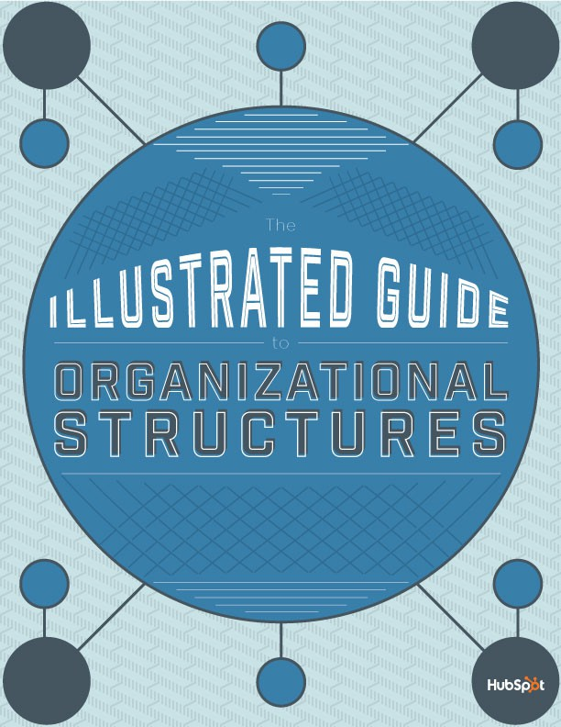



**TABLE OF CONTENTS**

1. 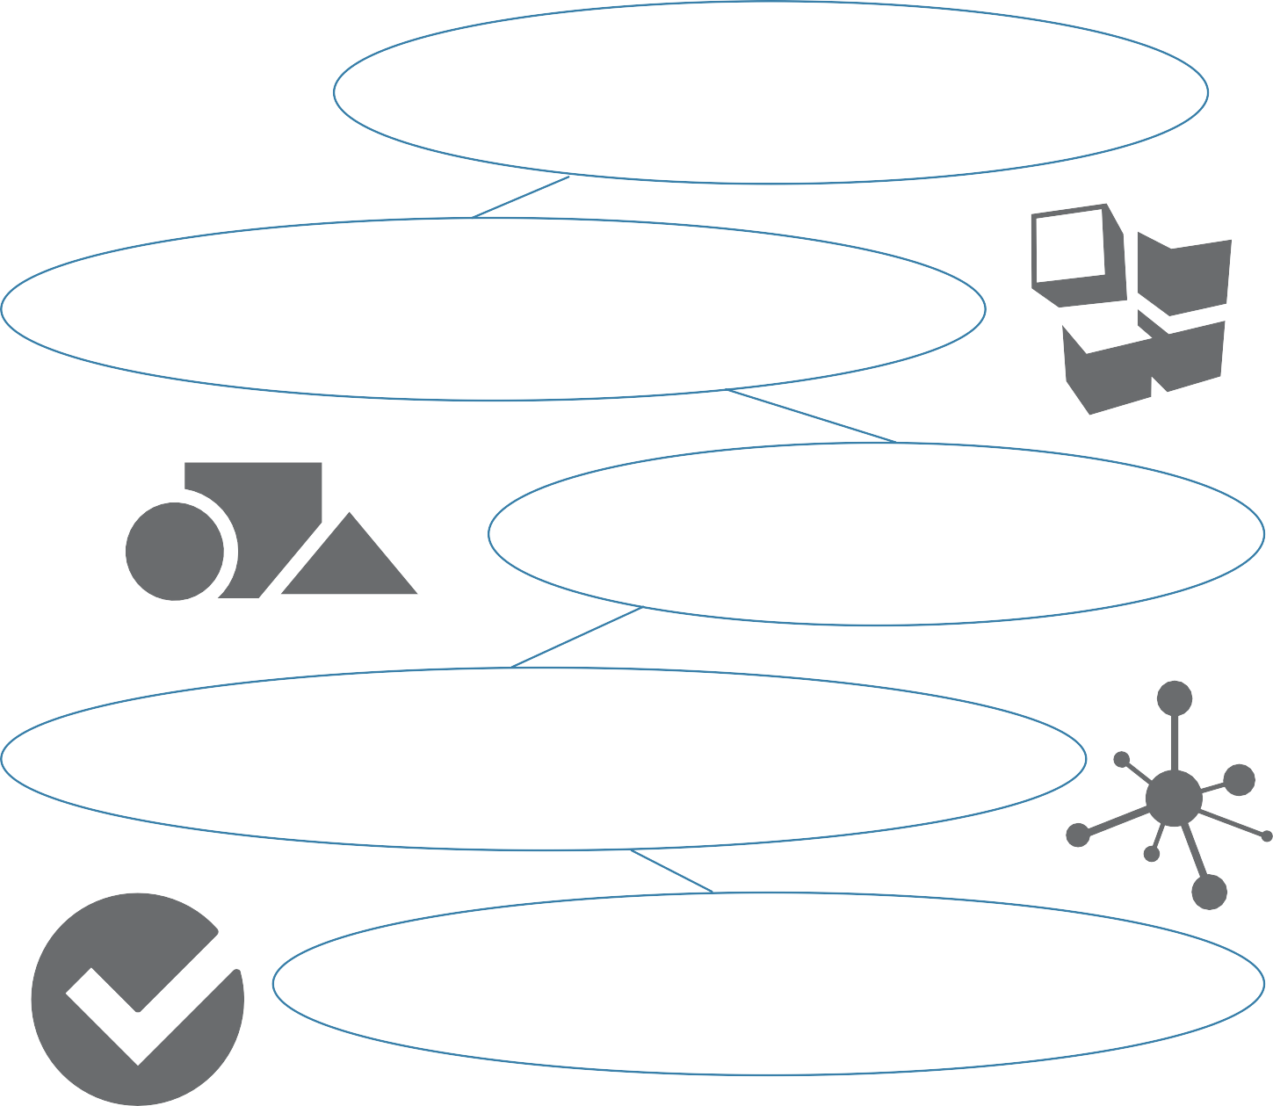An Introduction to Organizational Structures pg. 2
2. Building Blocks: Organizational Structure Basics pg. 3
3. Types of Organizational Structures pg. 8
4. Marketing Team Org Structures: 7 Real-World Examples pg. 17
5. How to Structure a Modern Marketing Team pg. 24

[Created by: **Erik Devaney** | @BardOfBoston | Content Strategist, HubSpot](https://twitter.com/BardOfBoston)



**INTRODUCTION**

To put it in the simplest terms possible, an organizational structure describes how a company, division, team, or other organization is built; how all of its various components fit together.



More specifically, it is a framework that organizes all of the formal relationships within an organization, establishing lines of accountability and authority, and illuminating how all of the jobs or tasks within an

organization are grouped together and arranged.

Ideally, the type of structure your company, division, or team implements should be tailored to the specific organizational goals you’re trying to accomplish. Because ultimately, even if an organization is filled with great people, it can fall apart (or fail to operate efficiently) if the structure of the organization is weak.

As executive coach Gill Corkindale noted in a [*Harvard Business Review*](https://hbr.org/2011/02/the-importance-of-organization/)[article,](https://hbr.org/2011/02/the-importance-of-organization/) “Poor organizational design and structure results in a bewildering morass of contradictions: confusion within roles, a lack of co-ordination among functions, failure to share ideas, and slow decision-making bring managers unnecessary complexity, stress, and conflict.”

In this guide, we’ll explore the world of organizational structures by taking a visual approach. The guide includes several organizational structure diagrams (or “org charts”), which highlight structures that can be applied to entire businesses as well as to marketing departments and teams.



**BUILDING BLOCKS**

In this section, we’ll be looking at six components or building blocks that you can tweak and arrange in order to build an organizational structure.

# Chain of Command

One of the most basic elements of an organizational structure, chain of command is exactly what it sounds like: an unbroken line of authority that extends from the top of the organization (e.g. a CEO) all the way down to the bottom. Chain of command clarifies who reports to whom within the organization.

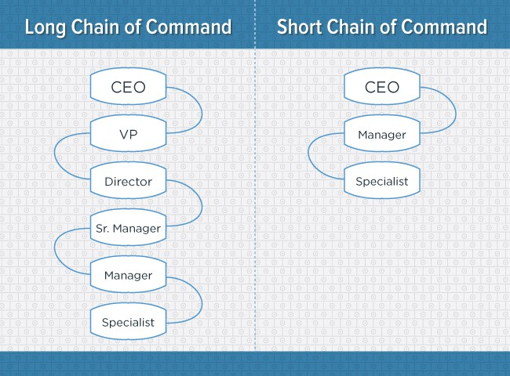

# Span of Control

Span of control refers to the number of subordinates a superior can effectively manage. The higher the ratio of subordinates to superiors, the wider the span of control.

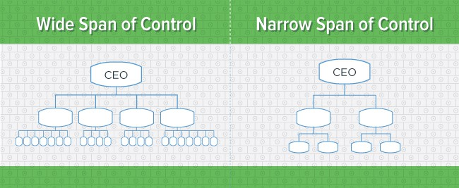

# Centralization

Who makes the decisions in an organization? If decision-making power is concentrated at a single point, the organizational structure is centralized. If decision-making power is spread out, the structure is decentralized.

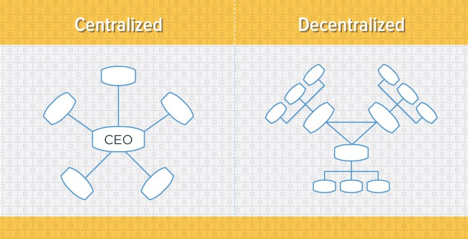

# Specialization

Also known as division of labor, specialization is the degree to which activities or tasks in an organization are broken down and divided into individual jobs.

High specialization can be beneficial for an organization, as it allows employees to become “masters” in specific areas, increasing their productivity as a result.

However, low specialization allows for more flexibility, as employees can more easily tackle a broader array of tasks (as opposed to being specialized for a single task).

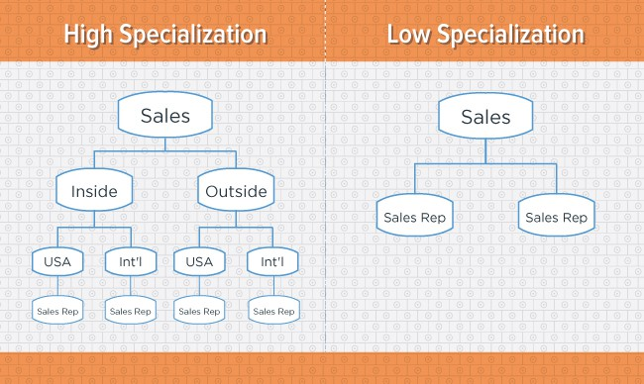

# Formalization

Similar to specialization, formalization deals with how jobs are structured within an organization. The key differentiator here is that formalization also takes into account the degree to which an employee’s tasks and activities are governed by rules, procedures, and other mechanisms.

A formal organizational structure seeks to separate the individual from the role or position, as the role or position stays the same regardless of who’s holding it.

An informal organization, on the other hand, places more value on the individual. It allows for the evolution of a role or position based on an individual’s preferences, skill set, etc., and places less importance on what team or department that individual is part of.

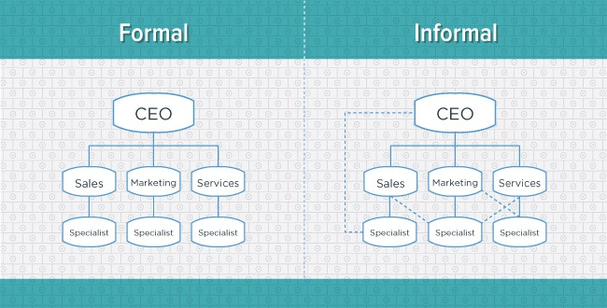

# Departmentalization

Departmentalization refers to the process of grouping jobs together in order to coordinate common activities and tasks.

If an organization has rigid departmentalization, each department or team is highly autonomous, and there is little (or no) interaction between different teams.

In contrast, loose departmentalization entails that teams have more freedom to interact and collaborate.

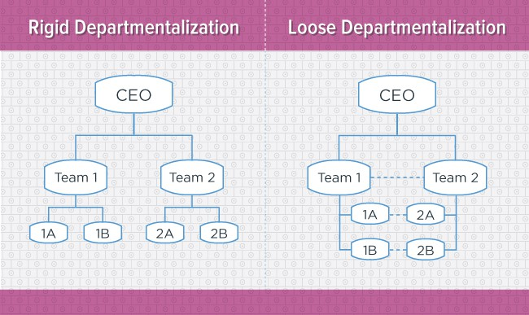

It’s worth noting that the way in which an organization departmentalizes is often used as a proxy for the overall type of organizational structure that organization has.

For example, an organization that departmentalizes by function (i.e. marketing, sales, services), is said to have a functional organizational structure.

We’ll talk more about functional organizational structures, in addition to other types of structures, in the next section.



**TYPES OF ORG STRUCTURES**

Now that you’ve learned about the building blocks of organizational structures, it’s time to explore how you can combine these blocks to form different types of structures.

# Mechanistic vs. Organic Structures

Organizational structures fall on a spectrum with “mechanistic” at one end and “organic” at the other end.

Mechanistic structures are typified by narrow spans of control; high centralization, specialization, and formalization; as well as by rigid departmentalization. And the chain of command, whether long or short, is always clear.

Oppositely, organic structures (also known as “flat” structures) are typified by wide spans of control; decentralization; low specialization and formalization; and loose departmentalization. And the chain of command, whether long or short, can sometimes be difficult to decipher.

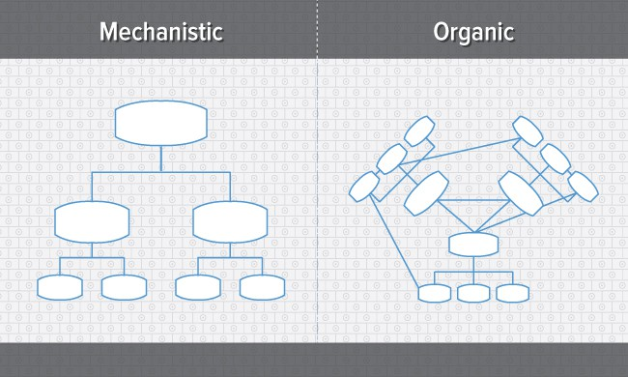

As you’ve probably been able to infer from their respective characteristics, the mechanistic structure represents the traditional, top-down approach to organizational structure, whereas the organic structure represents a more collaborative, flexible approach.

In this rest of this section, we’ll uncover more specific types of organizational structures, most of which fall on the more traditional, mechanistic side of the spectrum.

# Functional Org Structure

One of the most common types of organizational structures, the functional structure departmentalizes an organization based on common job functions. So, for example, an organization with a functional structure would group all of the marketers together in one department, group all of the salespeople together in a separate department, and group all of the customer service people together in a third department.

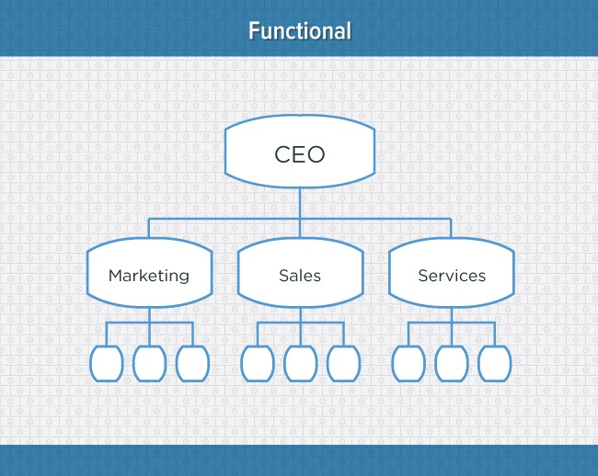

The functional structure allows for a high degree of specialization for employees, and is easily scalable should the organization grow. However, the structure also has the potential to create barriers between different functions, and can be inefficient if the organization has a variety of different products or target markets.

# Divisional: Product-Based Org Structure

You can think of a divisional organizational structure as a structure that’s comprised of multiple, smaller functional structures (i.e. each division within a divisional structure can have its own marketing team, its own sales team, etc.).

In this case -- a product-based divisional structure -- each division within the organization is dedicated to a particular product line. This type of structure is ideal for organizations with multiple products and can help shorten product development cycles. The downsides: it can be difficult to scale, and the organization may end up with duplicate resources as different divisions strive for autonomy.

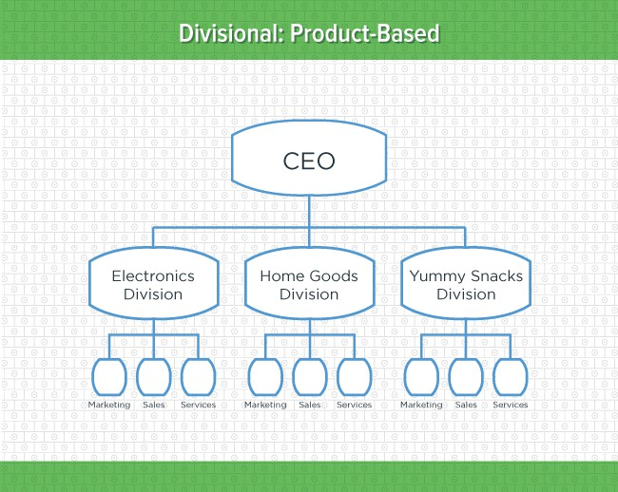

# Divisional: Market-Based Org Structure

Another variety of the divisional organizational structure is the market-based structure, wherein the divisions of an organization are based around markets, industries, or customer types.

The market-based structure is ideal for an organization that has products or services that are unique to specific market segments, and is particularly effective if that organization has advanced knowledge of those segments. The downsides: too much autonomy can lead to divisions developing systems that are incompatible with one another, and divisions may also end up inadvertently duplicating activities that other divisions are already handling.

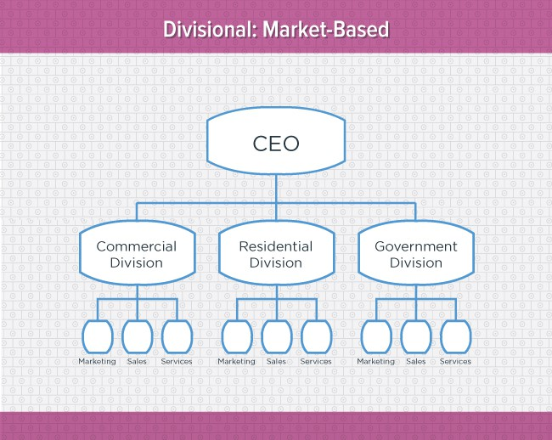

# Divisional: Geographical Org Structure

The geographical organizational structure establishes its divisions based on -- you guessed it! -- geography. More specifically, the divisions of a geographical structure can include territories, regions, or districts.

This type of structure is best-suited to organizations that need to be near sources of supply and/or customers (e.g. for deliveries, or for on-site support).

The main downside of a geographical org structure: it can be easy for decision- making to become decentralized, as geographic divisions -- which can be hundreds, if not thousands of miles away from corporate headquarters -- often have a great deal of autonomy.

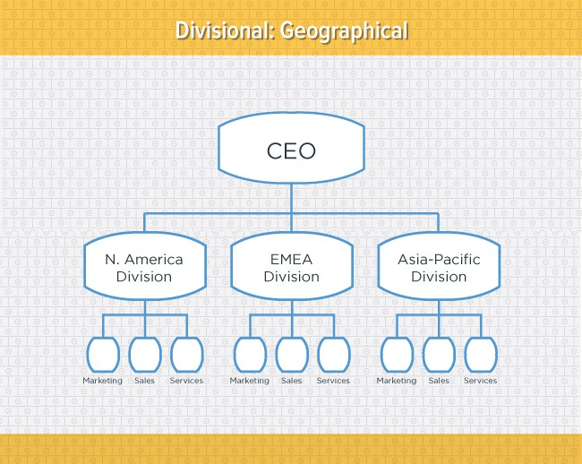

# Process-Based Org Structure

Process-based organizational structures are designed around the end-to-end flow of different processes, such as research & development, customer acquisition, and order fulfillment. Unlike a strictly functional structure, a process-based structure considers not only the activities employees perform, but also how those different activities interact with one another.

So, in order to fully understand the diagram below, you need to look at it from left to right: The customer acquisition process can’t start until you have a fully developed product to sell. And likewise, the order fulfillment process can’t start until customers have been acquired and there are product orders to fill.

This structure is ideal for improving speed and efficiency, and is best-suited to rapidly changing business environments, as it is easily adaptable. The main downside of a process-based org structure: barriers between the different process groups can lead to problems communicating and handing off work.

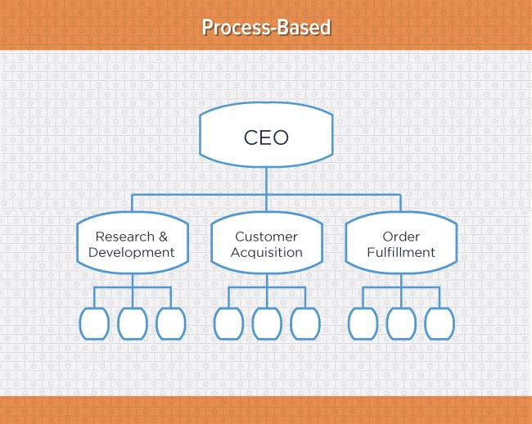

# Matrix Org Structure

Unlike the other structures we’ve looked at so far, a matrix organizational structure doesn’t follow the traditional, hierarchal model. Instead, all employees (represented by the green boxes) have dual reporting relationships.

Typically, there is a functional reporting line (shown in blue) as well as a product- based reporting line (shown in yellow). When looking at a matrix structure org chart, solid lines represent strong, direct-reporting relationships, whereas dotted lines indicate that the relationship is secondary, or not as strong. So, in our example below, it’s clear that functional reporting takes precedence over product-based reporting.

The main appeal of the matrix structure is that it can provide both flexibility and more balanced decision-making (as there are two chains of command instead of just one). Its primary pitfall: complexity, which can lead to confused employees.

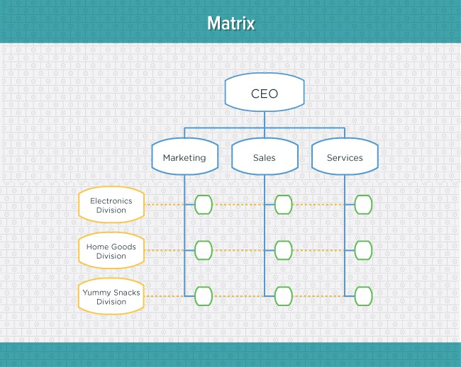

# Circular Org Structure

While it might appear drastically different from the other organizational structures highlighted in this section, the circular structure still relies on hierarchy, with higher- level employees occupying the inner rings of the circle and lower-level employees occupying the outer rings.

That being said, the leaders or executives in a circular organization aren’t seen as sitting atop the organization, sending directives down the chain of command. Instead, they’re at the center of the organization, spreading their vision outward.

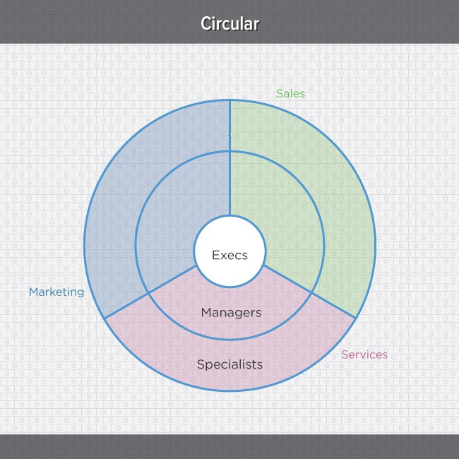

From an ideological perspective, a circular structure is meant to promote communication and the free flow of information between different parts of the organization. Whereas a traditional structure shows different departments or divisions as occupying individual, semi-autonomous branches, the circular structure depicts all divisions as being part of the same whole.

From a practical perspective, however, the circular structure can be confusing, especially for new employees. Unlike with a more traditional, top-down structure, with a circular structure it can be difficult for employees to figure out who they report to and how they’re meant to fit into the organization.

*In the next section, we’ll explore some examples of organizational structures that actual marketing teams utilize.*

*You’ll likely notice that these structures don’t always fit neatly into the structure types we just learned about. Instead, in real-world applications, organizations often use hybrid structures, which borrow elements from a variety of different structure types.*



**MARKETING ORG STRUCTURE EXAMPLES**

In this section, we’ll explore organizational structures at the marketing team level. The examples shown here originally appeared in our SlideShare presentation, [“The](http://www.slideshare.net/HubSpot/the-cmos-guide-to-marketing-org-structure) [CMO’s Guide to Marketing Org Structures”](http://www.slideshare.net/HubSpot/the-cmos-guide-to-marketing-org-structure)

# HubSpot (The Inbound Org Structure)

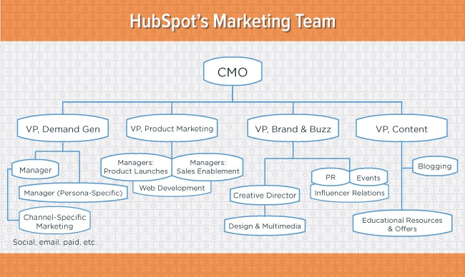

## Key Features:

* + Focused on providing a buyer-driven inbound experience.
  + Adds value through content and contextual marketing (e.g. [dynamic, smart site](http://www.hubspot.com/products/how-personalization-works) [pages](http://www.hubspot.com/products/how-personalization-works) and content based on a prospect’s relationship to the company).
  + Steeped in buyer personas and delivering experiences tailored to those personas.
  + Content as a dedicated function allows it to serve multiple internal “clients” (demand generation, PR, sales enablement).

# Zendesk (The TOFU Org Structure)

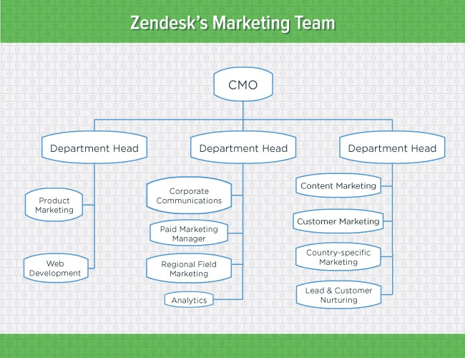

## Key Features:

* + This is a team built to scale top-of-funnel (“ToFu”) growth, with content marketing as the largest group, followed by advertising and product marketing.
  + Tight alignment with the creative team is key – the head of the creative team reports to the CEO, and the department straddles both marketing and product.

# Mindjet (The Elastic Org Structure)

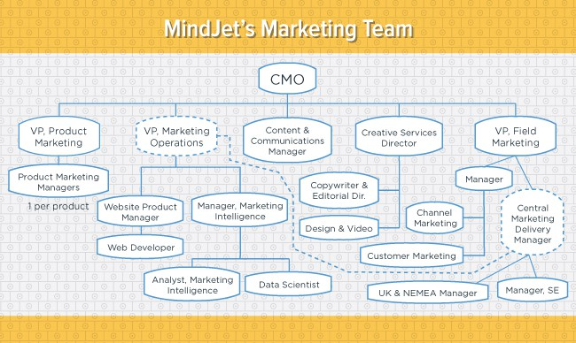

## Key Features:

* + Flexible structure allows for adding headcount and/or functions seamlessly as the company’s product mix evolves.
  + Much of the marketing org flows through Product Marketing Managers (PMMs).
  + PMMs partner with functional experts in other sub-departments.
  + Marketing Operations professionals oversee the complexity of the marketing tech stack, IT integration, hypothesis testing, and optimizing customer experiences in the product.

# Forrester (The Funnel-Focused Org Structure)

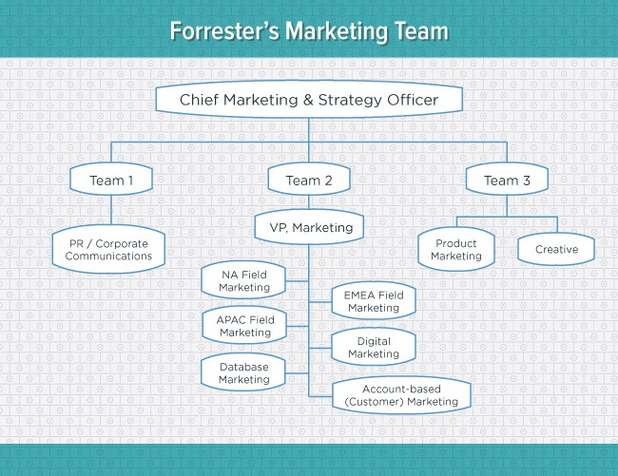

## Key Features:

* + Team 1 manages relationships with the top 50 publications, and places Forrester analysts to speak at industry events.
  + Team 2 focuses primarily on demand.
  + Team 3 manages product collateral for the sales team and the production of anything that carries the Forrester brand.
  + Put another way, Team 1 is above the funnel, Team 2 is top and middle of the funnel, and Team 3 creates materials for the bottom of the funnel and acts as a service bureau to the rest.

# GitHub (The Culture Org Structure)

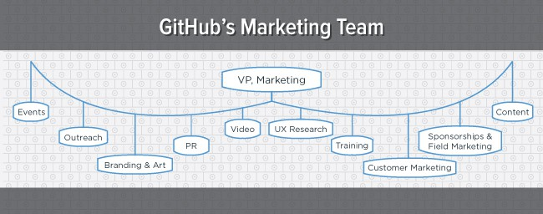

## Key Features:

* + In this flat organization, everything is based on merit. Very few titles exist – only team names.
  + The goal of marketing in this org is to transfer the culture everywhere, in the product that’s built, the marketing assets used to drive awareness and adoption ... even internally.
  + In this org, more than just defined “marketers” take part in marketing. The entire company is expected to uphold the culture of the company, whether through offline events, social media, or one-to-one user interactions.

# Rue La La (The Creative Org Structure)

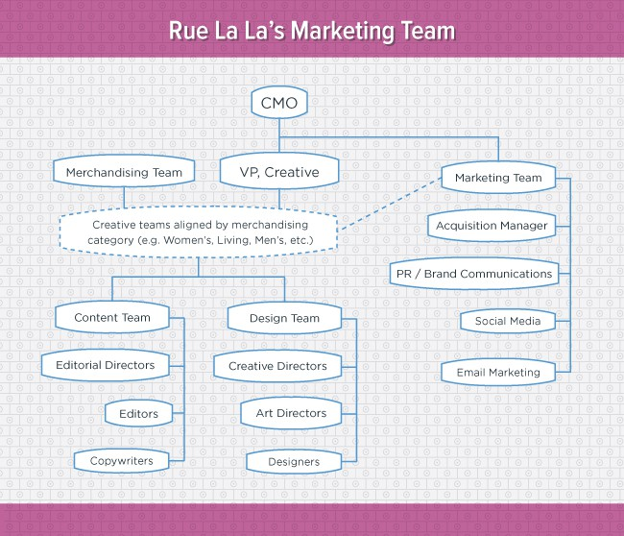

## Key Features:

* + Marketing, merchandising, and creative align to provide Rue La La members with a fully integrated, seamless shopping experience.
  + Marketing is organized by disciplines (such as acquisition, PR, or social) across each business category (e.g. fashion, home, travel). The general manager of each business line sets the overall objective.

# Atlassian (The Customer Org Structure)

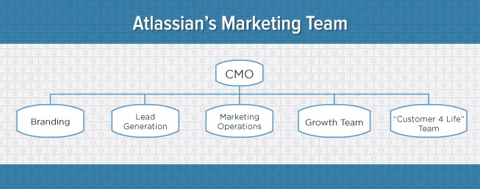

## Key Features:

* + Built with a focus on the marketing funnel, from awareness-based branding to lead generation and nurturing, to customer retention.
  + The bottom of the funnel receives a great deal of attention, as the “Customer 4 Life” team exists specifically to nurture and retain existing customers. The team’s goal is to improve customer success on existing products (i.e. retention) while upselling new features.
  + Marketing Ops supports the rest of the organization.



**STRUCTURING YOUR TEAM**

In this section, we’ll be looking at how you should structure a modern marketing team based on your team’s headcount.

Before we dive in, it’s important to understand that when it comes to organizational structure, there is no magic bullet. The success of a marketing team (or a business, for that matter), doesn’t rest solely on the structure that underlies it.

Poor management and decision-making can disrupt any organization, regardless of how well it’s structured. And while restructuring your organization (a.k.a. doing a “re-org”) might seem like an appealing option for increasing efficiency, it’s not something to be taken lightly: [A re-org can be a very difficult and complex process.](https://hbr.org/2011/03/solving-the-rubiks-cube-of-org/)

That being said, if you’re looking to build an *inbound* marketing team (i.e. a team that follows the [inbound methodology](http://www.hubspot.com/inbound-marketing) of attracting visitors, converting visitors into leads, and closing leads into customers), we have some best practices you can follow.

For starters, you’ll need to think about how members of your marketing team fit into the stages of the inbound methodology. Here’s a quick breakdown of which roles belong where:



**ATTRACT**

Your content writers, designers, SEO specialists, and social media managers.



**CONVERT**

Everyone involved in conversion optimization, including landing pages, calls-to-action, lead scoring, and nurturing.



**CLOSE**

Your sales enablement marketers helping the sales team close

opportunities.

On the next page, we’ll explore how you should organize these roles based on your team’s headcount.

# Organizational Structure by Team Size

The following org charts are derived from a presentation HubSpot’s CMO Mike Volpe gave at [INBOUND 2014](http://www.inbound.com/). The charts depict the ideal structures of inbound marketing teams based on team size, and show which stage of the methodology each team member should be responsible for.

For Mike’s full synopsis on this subject, check out his blog post, “[How to Structure a](http://blog.hubspot.com/marketing/how-to-structure-marketing-team) [Marketing Team of Any Size](http://blog.hubspot.com/marketing/how-to-structure-marketing-team).”

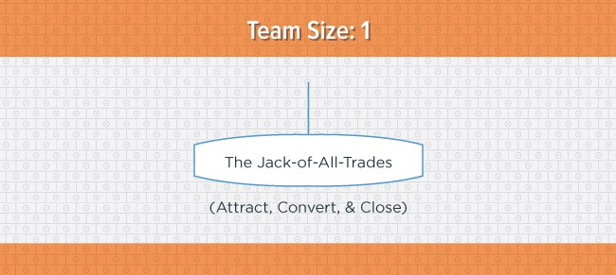

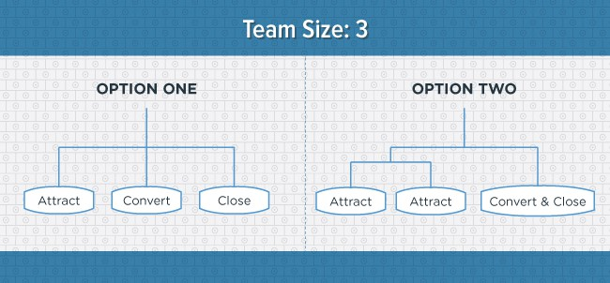

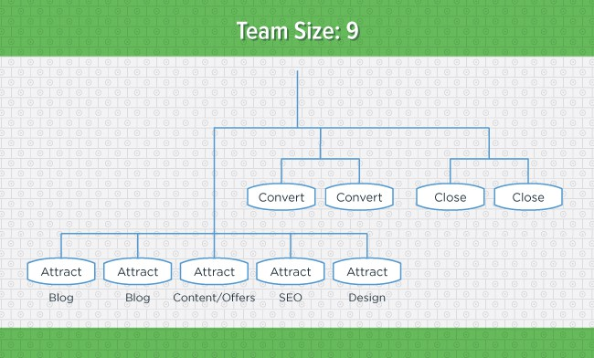

*“Notice how many [team members] fall under the ‘attract’ bucket. Chances are this isn’t what your team looks like right now.*

*The biggest mistake I see marketing leaders make is over-investing in marketers who specialize in the bottom of the funnel. In fact, the best way to help your sales team is to build brand awareness and create content that generates a lot of leads over time.*

*An increase of twice as many leads means twice as many quality leads -- as long as you have software that lets you filter those incoming leads efficiently. That’s how you build a successful sales and marketing machine.”*

(Excerpt from “[How to Structure a Marketing Team of Any Size](http://blog.hubspot.com/marketing/how-to-structure-marketing-team).”)

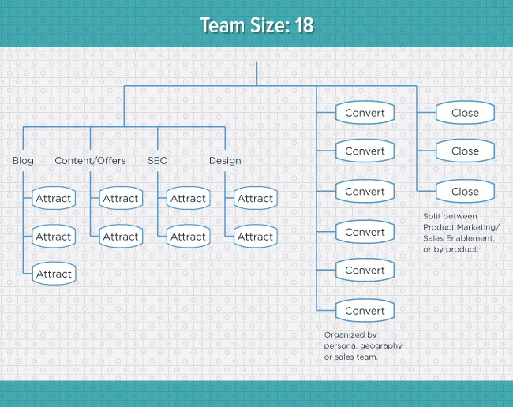

The big takeaway from these charts? Always build out the “attract” segment of your marketing team first. Why? Because the long-term benefits of content -- both blog content and longer-form content “offers” -- are enormous.

Content is an investment. Create it early (and often) and it will continue to pay off for years to come.

Want to dive deeper and learn how to structure a content team? Check out this SlideShare presentation: “[The Anatomy of the Corporate Content Team: 5 Models](http://blog.hubspot.com/marketing/content-team-structure) [to Inspire Your Team’s Structure](http://blog.hubspot.com/marketing/content-team-structure).”



**RESOURCES**

Thanks for reading!

If you’d like to take a more academic look at organizational structures, be sure to explore some of the following resources:

* [Frameworks for Organizational Design (Corporate Leadership Council)](http://isites.harvard.edu/fs/docs/icb.topic608877.files/Class%20Nine%20Reading/CLC_Frameworks_for_Organizational_Design.pdf)
* [Fundamentals of Organization Structure (University of North Florida)](http://www.unf.edu/~gbaker/Man4201/Chapt003a.PDF).
* [The Importance of Organizational Design and Structure (*Harvard*](https://hbr.org/2011/02/the-importance-of-organization/) [*Business Review*](https://hbr.org/2011/02/the-importance-of-organization/))
* [Solving the Rubik’s Cube of Organizational Structure (*Harvard Business*](https://hbr.org/2011/03/solving-the-rubiks-cube-of-org/)[*Review*)](https://hbr.org/2011/03/solving-the-rubiks-cube-of-org/)
* The Decision-Driven Organization [(*Harvard Business Review*)](https://hbr.org/2010/06/the-decision-driven-organization/ar/1)

And here are a couple of HubSpot resources you might find helpful:

[](http://offers.hubspot.com/ready-to-use-marketing-job-descriptions)[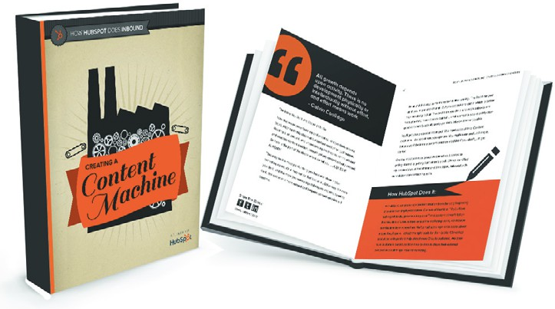](http://offers.hubspot.com/how-hubspot-does-inbound-creating-a-content-machine)

[Pre-Written Job Descriptions](http://offers.hubspot.com/ready-to-use-marketing-job-descriptions) [Creating a Content Machine](http://offers.hubspot.com/how-hubspot-does-inbound-creating-a-content-machine)



**RATE THIS CONTENT**

us improve!

content

and

help

to rate

this

Click below

[](http://offers.hubspot.com/rating-our-content?content_title=org%2Bstructures&content_format=ebook&offer_by_author=Erik%2BDevaney)

[](http://offers.hubspot.com/rating-our-content?content_title=org%2Bstructures&content_format=ebook&offer_by_author=Erik%2BDevaney)

**Learn More About HubSpot’s All-in-One Marketing Platform**

HubSpot brings together all of the tools you need to attract, convert, close and delight customers, including marketing automation. See all of our tools, learn more about

inbound marketing, or talk to a specialist today.



        

**Landing Pages Forms Lead**

**Management**

**Email**

**Marketing Automation**

**Analytics Salesforce**

**Social Inbox Blogging**

**Sync**



[**Learn more about inbound marketing**](http://www.hubspot.com/inbound-marketing)



[**See the software**](http://www.hubspot.com/products)



[**Talk to a specialist**](http://offers.hubspot.com/contact-sales)

**LEADERSHIP AND MOTIVATION**

**CONTENTS:**

**Motivation- Nature and Importance of Motivation,**

**Motivation Theories - Maslow’s Need Hierarchy Theory, Hertzberg’s Two Factor Theory, McGregor’s Theory X and Theory Y**

**Leadership – Nature and Importance, Qualities of Good Leaders, Types, Theories of Leaders (Contemporary leadership)**

# MOTIVATION

Motivation is a psychological phenomenon which generates within an individual. Motivation is a state-of-mind, filled with energy and enthusiasm, which drives a person to work in a certain way to achieve desired goals. Motivation is a force which pushes a person to work with high level of commitment and focus even if things are against him.

# FEATURES OF MOTIVATION

1. Motivation is an act performed by manager.
2. Motivation produces goal-oriented behavior.
3. Motivation is a personal and internal feelings.
4. Motivation can be positive or negative. Positive motivation indicates rewards whereas negative indicates punishments.
5. Motivation is a continuous process.
6. Motivation is system oriented.
7. Individual differs in the terms of motivation even through performing homogenous tasks.
8. Motivation is deeply influenced by a given situation. NATURE OF MOTIVATION

The following inferences can be drawn from the meaning of motivation:

1. Motivation is a inner feeling which energizes a person to work more.
2. The emotions or desires of a person prompt him for doing a particular work.
3. A person moves to fulfill his unsatisfied needs by conditioning his energies.
4. There are dormant energies in a person which are activated by channelizing them into actions.

# IMPORTANCE OF MOTIVATION

The following is the importance of motivation:

1. **High Performance:** Motivated employees will put maximum efforts for achieving organisational goals. Better performance will also result in higher productivity. The

cost of production can also be brought down if productivity is raised. The employees should be offered more incentive for increasing their performance.

1. **Low Employee Turnover and Absenteeism:** When the employees are not satisfied with their job then they will leave it whenever they get an alternative offer. The dissatisfaction among employees also increases the absenteeism. When the employees are satisfied with their job and they are well motivated by offering them financial and non-financial incentives the employee turnover will reduce, and the rate of absenteeism will also come down.
2. **Better Industrial Relations:** A good motivational system will create job satisfaction among employees. The employment will offer them better service conditions and various other incentives. There will be an atmosphere of confidence among employers and employees.
3. **Creates Supportive Work Environment:** When the needs of employees are satisfied and they get proper recognition, then they will have a positive attitude towards work. The relations between superiors and subordinates will be cordial and working environment will improve.
4. **Helpful in changing Attitude of Employees:** In the absence of motivation, the employees will be taking the work in a routine way and will not think of doing their best.
5. **Acceptability to Change:** The changing social and industrial situations will require changes and improvements in the working of enterprise. When the employees are given various opportunities of development then they can easily adopt to new situations. Motivation will ensure the acceptability of new changes by the employees.
6. **Delegation of Authority:** If a subordinate is given a substantial amount of responsibility to execute a given task, it can prove to be a very strong motivating factor. The subordinate feels that since the supervisor has shown trust in him, he must show results.
7. **Reinforcement:** Reinforcement is a very powerful motivational tool. These include the following reinforcement techniques: -
   1. Positive
   2. Negative
   3. Extinction
   4. Punishment

The first two reinforces namely positive and negative reinforcements both seek to encourage desirable behaviour by different approaches. The remaining two enforcers namely punishment and extinction both seek to discourage undesirable behaviour through different approaches. The use of a particular strategy will depend upon the type of situation faced. Organisations, now-a-days are making use of this technique for modifying the behaviour of organization members, so that they are engaged in desirable behaviour.

1. **Job Rotation**: Job rotation implies shifting of an employee from one job to another in order to provide some variety so as to minimize monotony and boredom. The basic

objective of job rotation is to increase the knowledge and skill of the employees about related jobs. In job rotations employees learn to do different activities necessary for an operation or unit of work.

# THEORIES OF MOTIVATION

The human nature is so complex that it responds unpredictably at different times. The motivators differ from time to time, place to place and situation to situation and person to person. Due to enormous effect of motivational factors on the working behaviour and level of performance of the employee, lot of research work has been done and as a result of that many theories of motivation have been developed. Some of these theories are discussed as follows:

1. Maslow’s Need Hierarchy Theory
2. Herzberg’s Hygiene-Two factor Theory.
3. Mc Gregor’s ‘X’ and ‘Y’ Theory

# MASLOW’S NEED HIERARCHY THEORY

The first theory of motivation was introduced by Abraham Maslow’s, an American social scientist popularly termed as Maslow’s hierarchy of needs introduced in the year 1943 in his article named as a theory of human motivation. He has categorised human needs into five categories. He is of the opinion that a person tries to achieve first category first then moves on to the next and so on.

According to Maslow the Hierarchy of needs are as follows: -

* 1. Physiological Needs
  2. Safety Needs
  3. Social Needs
  4. Esteem Needs
  5. Self Actualisation Needs

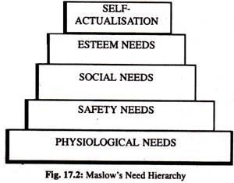

# ASSUMPTIONS

1. **Physiological needs:** These are the basic needs for sustaining human life itself, such as food, water, shelter, and sleep. A man will try to satisfy these needs first. Maslow took the position that until these needs are satisfied to the reasonable degree necessary to maintain life, other needs will not motivate people.
2. **Security or safety needs:** Once physiological needs are satisfied then safety need take over. Health and wellbeing financial security Safety of property against natural disasters Law and Order. People want to be free of physical danger and of the fear of losing job, property, or shelter.
3. **Social needs:** After having secured satisfaction for physical needs and protection for future one focus next on satisfying needs of love and affection which are known as social needs. Since people are social being, they need to belong, to be accepted by others. They start forming their own groups and association.
4. **Esteem needs:** Once people begin to satisfy their need to belonging, they tend to want to be held in esteem both by themselves and by others. This kind of need produces such satisfaction as power, prestige, and status. Esteem needs include need for self-respect and appreciation from others, status, and prestige in the society.
5. **Self-actualization needs:** Self-fulfilment is the highest need in Maslow’s hierarchy

This refers to the needs which helps an individual to develop his personalities. The self- fulfilment needs give satisfaction to the person concerned and are good for the society also. It is desired to become what one is capable of becoming to maximize one’s potential and to accomplish something.

Maslow has categorised the needs in order of priority. When one need is satisfied then the other becomes the motivator. All the needs are interdependent. It is not necessary that only one need is satisfied at one time.

# HERZBERG’S TWO FACTOR THEORY

Fredrick Herzberg and his associates have proposed a two factors theory of motivation. one group of needs are such things as company policy and administration, supervision, working conditions, interpersonal relations, salary, job security and personal life. These are called as dis-satisfiers and not motivators. If they exist in a work environment, they yield no dissatisfaction. Their existence does not motivate but their absence result dis- satisfaction. Hertzberg called these factors as hygiene or maintenance factors. The second group he listed certain satisfiers and therefore motivators, which are related to job content. They include achievement, recognition, challenging work, advancement and growth in the job.

It was introduced by Frederick Herzberg popularly termed as two factor theory in the year 1959.According to him factors affecting motivation are two types of namely hygiene and Motivation

1. **Hygiene factors**: They are extrinsic factors and include factor like: salary,

job security,

company policy and administration, supervision and working conditions.

these factors do not motivate a person and however they provide working environment. Inadequacy of extrinsic factors lead to job dissatisfaction, and in turn their presence does not promote job satisfaction.

1. **Motivators**: They are intrinsic factors which includes: sense of achievement,

recognition,

responsibility and personal growth,

opportunity for personal development and they determine satisfaction of given task to a worker.

Most of the motivational factors relate to job contents. The increase in these factors will be essential for increasing the motivation of the employees. It can be said that motivation factors contribute heavily to the satisfaction of employees and have a positive effect on their performance.

# MC GREGOR’S ‘X’ AND ‘Y’ THEORY

Douglas Mc Gregor, US behavioural scientists has developed approach to manage and motivate based on various assumptions relating to human behaviour. It has formulated as theory X and theory Y. Both these theories are founded on certain assumptions regarding human behaviour.

## Assumptions underlying X theory of motivation.

* Workers inherently dislike work, and they attempt to avoid work whenever possible.
* Most workers are not ambitious they have little desire for responsibility and prefers to be directed.
* Majority of the workers have little creativity in solving organizational problem.
* Workers are self-centered and they must be closely monitored and forced to achieve organizational problems.
* Workers lack integrality.
* Workers are purely interested in retaining the jobs rather than achievement.
* Worker resist change
* Workers are gullible and unintelligent.

Autocratic and authoritarian leadership is suitable and preferred by these workers.

## Assumption underlying Y Theory of motivation.

* + Work can be natural as play if favorable conditions persist.
  + It is imprecise to assume that the workers are incompetent and are unable take right decision.
  + Workers are self-directed and creative in performing their tasks and achieving organizational objectives.
  + Creativity capacity spreads throughout the organization
  + Majority of the workers can shoulder responsibility because the culture of creativity and ingenuity are common in population.
  + For a worker financial reward is not only inspirational factor, even non-financial reward like recognition, higher responsibility, greater involvement in decision making is also equally important

# LEADERSHIP

According to Koontz and O’Donnell, “leadership is generally defined as influence, the art of process of influencing people so that they will strive willingly towards the achievement of group goals”. A leader is one who guides and directs other people.

A leadership is process and the ability to influence to lead and guide people to achieve common goals. In simple word the action of leading a group of people or an organization is a leadership.

Functions of leaders

The leaders while influencing the subordinates perform the following functions:

1. **Taking initiative:** A leader has to take all initiative to lead the business activities. He himself should come in the field and take all steps to achieve predetermined targets. Hence a leader is initiator.
2. **Guide:** A leader has the primary duty of guiding others by communicating instructions and orders.
3. **Representation:** A leader is a representative of the organization.
4. **Encouraging others:** A leader is the captain of the team. Encouragement is necessary to build teamwork. The leader must win the confidence of his colleagues.
5. **Arbitrator and mediator**: A leader has to create a smooth relationship among employees. In addition, he has to settle disputes arising among employees.
6. **Planner:** A leader makes decisions concerning the ways and means by which the organizational goals can be achieved.
7. **Administrator of rewards and punishments:** Leaders encourage, upgrade, promote deserving people and reprove, transfer, and fine inefficient workers.

# NATURE OF LEADERSHIP

* 1. Leadership is personal quality.
  2. It exists only with followers. If there are no followers, there is no leadership.
  3. It is the willingness of people to follow that makes a person a leader.
  4. Leadership is a process of influence. A leader must be able to influence the behaviour, attitude and beliefs of his subordinates.
  5. It exists only for the realization of common goals.
  6. It involves readiness to accept complete responsibility in all situations.
  7. Leadership is the function of stimulating the followers to strive willingly to attain Organisational objectives.
  8. Leadership styles do change under different circumstances.

# LEADERSHIP

According to Koontz and O’Donnell, “leadership is generally defined as influence, the art of process of influencing people so that they will strive willingly towards the achievement of group goals”. A leader is one who guides and directs other people.

A leadership is process and the ability to influence to lead and guide people to achieve common goals. In simple word the action of leading a group of people or an organization is a leadership.

Functions of leaders

The leaders while influencing the subordinates perform the following functions:

1. **Taking initiative:** A leader has to take all initiative to lead the business activities. He himself should come in the field and take all steps to achieve predetermined targets. Hence a leader is initiator.
2. **Guide:** A leader has the primary duty of guiding others by communicating instructions and orders.
3. **Representation:** A leader is a representative of the organization.
4. **Encouraging others:** A leader is the captain of the team. Encouragement is necessary to build teamwork. The leader must win the confidence of his colleagues.
5. **Arbitrator and mediator**: A leader has to create a smooth relationship among employees. In addition, he has to settle disputes arising among employees.
6. **Planner:** A leader makes decisions concerning the ways and means by which the organizational goals can be achieved.
7. **Administrator of rewards and punishments:** Leaders encourage, upgrade, promote deserving people and reprove, transfer, and fine inefficient workers.

# IMPORTANCE OF LEADERSHIP IN MANAGEMENT

The importance of leadership in any group activity is too obvious to be over-emphasised. Wherever there is an organised group of people working towards a common goal, some type of leadership becomes essential. Lawrence A. Appley remarked that the time had come to substitute the word leadership for management. Although the concern for leadership is as old as recorded history, It has become more acute during the last few decades due to the complexities of production methods, high degree of specialisation and social changes in the modern organisations.

A good dynamic leader is compared to a 'dynamo generating energy' that charges and activates the entire group in such a way that near miracles may be achieved. The success of an enterprise depends to a great extent, upon effective leadership. The importance of leadership can be highlighted from the following:

1. **It improves motivation and morale**. Through dynamic leadership managers can improve motivation and morale of their subordinates. A good leader influences the behaviour of an individual in such a manner that he voluntarily works towards the achievement of enterprise goals.
2. **It acts as a motive power to group efforts**. Leadership serves as a motive power to group efforts. It leads the group to a higher level of performance through its persistent efforts and impact on human relations.
3. **It acts as an aid to authority**. The use of authority alone cannot always bring the desired results. Leadership acts as an aid to authority by influencing, inspiring and initiating action.
4. **It is needed at all levels of management**. Leadership plays a pivotal role at all levels of management because in the absence of effective leadership no management can achieve the desired results.
5. **It rectifies the imperfectness of the formal organisational relationships**. No organisational structure can provide all types of relationships and people with common interest may work beyond the confines of formal relationships. Such informal relationships are more effective in controlling and regulating the behaviour of the subordinates. Effective leadership uses these informal relationships to accomplish the enterprise goals.
6. **It provides the basis for co-operation**. Effective leadership increases the understanding between the subordinates and the management and promotes co-operation among them.

# QUALITIES OF A GOOD LEADER

1. **Intelligence**. This trait is considered to be the most important trait. Leaders generally have higher level of intelligence than the average of their followers. Intelligence is the natural quality of a person, to a great extent, because it is directly related to the brain. As the human beings are born with their brains, it is generally said that "leaders are born and not made.”

Intelligence means ability to think scientifically, analyse accurately and interpret clearly and precisely the problems before them. Though it is a natural quality, psychologists claim that intelligence can be improved with the help of proper training programmes.

1. **Physiological Factors**. Physical features of a person determine his personality which, in turn, is an important factor in determining success of leadership. Height, weight, physique, health and appearance of an individual have a very strong impact on the personality and success of the leadership.
2. **Emotional Stability**. To be successful, a leader must have high level of emotional stability. He must be consistent in his actions, should not be biased and should know how to control anger. He must be well adjusted and self-confident personality who believes that he can handle most of the situations successfully.
3. **Intense Inner Motivational Drive**. Successful leaders generally have very intense inner motivational drives. They have the inner urge to keep on accomplishing something all the time. Not only should he be self-motivated, but he must have the requisite quality to motivate the others also. He should play an active role in stimulating the inner drives of his followers also.
4. **Human Relations Attitude**. Success of a leader depends on cooperation of the people. That is why, a successful leader must possess the human relations attitude. He should always try to develop social understanding with other people. He should have intimate knowledge about the people and the interpersonal relationships. It is very important for a leader to possess knowledge of how human beings react to different situations.
5. **Vision and Foresight.** A successful leader should have the capability to look into future and visualise trends and devise his policies and programmes with foresight based on logical programmes.
6. **Empathy**. Empathy is the ability of a person to observe the things or situations from the point of view of others. Empathy is an important aspect of successful leadership. An effective leader should know what makes the other fellow think as he does, even though he does not necessarily agree with him. On the basis of empathy he can predict and understand the behaviour of people but for that he must have an understanding of the rights, beliefs, values and feelings of other people.
7. **Fairness and Objectivity**. A good leader must show fairness and objectivity in his dealings with his subordinates. He should not be biased, and he should not allow himself to become emotionally involved to the extent that it becomes difficult to make an objective diagnosis and implement the required action.
8. **Technical Skills**. Planning, organising, delegation, analysis, seeking advice, making decisions, controlling and winning cooperation constitute technical competence of leadership. A leader can win support from his subordinates with his /her technical skills.
9. **Open Mind and Adaptability**. Flexibility or open mindedness is a quality which makes a leader more identified with the group. He should not be critical of others. He must accommodate the viewpoint of others and should be willing to modify his decision on the basis of that.
10. **Art of Communication**. To be successful a leader must know how to communicate effectively. Good communication skills can be used for persuasive, informative and stimulating purposes. A successful leader is generally an extrovert and a self-confident person.
11. **Social Skills**. Social skills play a very important part in successful leadership. A leader should know the plus and minus points of his subordinates. He should have the ability to work with his people in such a way that he wins their confidence and loyalty. A successful leader is one with whom people cooperate willingly and not under any pressure.

# THEORIES OF LEADERSHIP

Different authors hold different views on the qualities that are considered essential for effective leadership. The main theories or approaches that have evolved have been discussed below:

## The Trait Theory

The trait theory represents the earliest notions of leadership and was popular between 1930 and 1950. According to this theory the behavior scientists have listed out the personal characteristics or traits of successful leaders. Some of the traits of successful leaders are good personality, flexibility, Imagination, emotional stability, desire to accept responsibility, self-confidence, honesty, sincerity, persuasive power. It is presumed that the person possessing these traits could become successful leaders.

## The Behavioural Theory

The behavioural theory emphasis on the actual behaviour and action of the leaders as against personal qualities or traits of leaders. According to this approach, leadership involves interpersonal relationship between a leader and subordinates in which the behaviour of the leader towards the subordinate constitutes the most critical element. The

effectiveness of leadership in the theory is the role played or the behaviour exhibited by the leader. According to this, the leaders use technical, Human and concept skill to lead his follower towards the achievement of goals of the organization. The good behaviour of the leader raises the morale, builds up confidence and spirit among the team members and lack of good behaviour will discard him as a leader.

## The Situational Theory

The Situational theories emphasise not on personal qualities or traits of a leader, but upon the situation in which he operates. The advocates of this approach believe that leadership is greatly affected by a situation and maintain that leadership pattern is the product of situation at a particular time. A good leader is one who moulds himself according to the needs of a given situation.

## The Contingency theory

Contingency theory was developed to focus on situational influences on leadership effectiveness suggested that under condition a, style x would be appropriate whereas style y would be more suitable for condition b.

There are two contingencies' theories:

* 1. Fiedler Model: This theory was developed by Fred Fiedler. This model proposes that effective group performance depends on the proper match between leader’s style and the degree to which the situation gives control to the leader.
  2. Leader-Member Exchange Theory (LMX): This theory argues that because of time pressures, leaders establish a special relationship with a small group of their followers. These individuals make up the in-group: they are trusted and get a disproportionate amount of the leader’s attention. Others fall into the out-group- they get loss of the leader’s time, few of the preferred rewards that the leader controls, and have leader-follower relations based on formal authority interactions.

## The Continuum Theory

Tannenbaum & Schmidt developed this theory which states that the appropriate style of leadership depends on the leader, subordinate & the prevailing situation.

The forces influencing the leadership style are:

1. The forces operating in manager’s personality.
2. The forces in the subordinates
3. The forces in the situation

## The Follower Theory

According to this theory only followers decide whether a person is leader or not. Followers take a decision analysing the qualities of a person who helps to have their needs fulfilled. Here there is a need for forming a group and fulfilling some needs of such group. This theory cannot be applied without a group of followers.

## The Path- Goal Theory

System theory is focused on person’s act rather than his traits or behaviour. A leader coordinates the efforts of his follower. The process of co – ordination is done by person

called leader. The system theory considers all variables includes the leader, follower, situation, leadership traits, environment goals and groups nature.

# DIFFERENT LEADERSHIP STYLES

1. **Autocratic or Authoritarian Style Leader:** An autocratic, also known as authoritarian style of leadership implies yielding absolute power. He does not consult his subordinates he takes all the decision by himself. He also takes full responsibilities for his decisions. The subordinates must obey him without asking any question.

## Advantages

1. The decision making is quick.
2. Provides motivation and inspiration to the leader since he dictates the terms.
3. Provides positive results when things need to be done with speed.

## Disadvantages

1. Leads to low morale and frustration among employees.
2. Subordinates avoid initiative.
3. Creativity and potential of subordinates is not utilized.
4. **Free reign/laissez-faire style:** The **Laissez-Faire or Free-Rein** is the leadership style wherein the leader gives full freedom to his subordinates to act on their own. Here, the leader once defines the goals, policies, programs and the limitations for action and then leaves the remaining process to be accomplished by the subordinates on their own.

This type of leadership creates self-confidence in the subordinates and provides them an opportunity to develop their talents.

This type of leadership may not work under all situations and with all types of subordinates. Such leadership can be employed with success where the subordinates are competent, sincere and self-disciplined.

1. **Democratic /participative style**: Participative type of leader encourages his subordinates to take part in the decision making. The final decision is not taken by the leader himself. It is taken by a group (team) i.e., by the leader and his subordinates. Under their leadership, everyone is encouraged to participate, leading to increased feelings of involvement, recognition, and satisfaction.

This style of leadership is suitable under the following situations:

* 1. When leader wants participation of subordinates in decision making,
  2. When the company wants to increase job satisfaction of employees

1. **Bureaucratic or Rules Centered leader**: Bureaucratic leader follows all the rules and formalities of the organization. Here, rules, policies, and hierarchies form a clear set of expectations as well as an explicit chain of command. New ideas and initiatives are not encouraged and there is delay in taking decisions.
2. **Paternalistic leader:** Paternalistic style creates a family atmosphere in the organization. He acts just like a parent of his subordinates. he advises, guides, helps his subordinates in with

their personnel problem. This type of leadership style will be successful in small organization a very few employees and only one leader. The subordinates become dependent on the leader.

1. **Manipulative Leadership Style:** Manipulative leaders use position, power, and coercion to derive their outcomes. They confuse people. They falsely believe that these manipulative characteristics and behaviors will yield them success. There is a feeling of distrust when the manipulative nature of the leader is evident, and the employee feel cheated. This type of leadership is useful when co-operation of employees is needed urgently for a specific task.

## Formal and informal Leader:

**Formal leader:** He/ she is the leader who is formally appointed/ elected & created by formal structure. They enjoy 2-fold responsibilities, authority & are also accountable. They are supposed to guide, help, and direct their subordinates.

**Informal leader:** These leaders are not formally recognized & command respect from people who approach them for guidance & help. They perform the task of achieving individual & group goals & thus strengthen the formal leadership.

Group Dynamics

*“Never doubt that a small group of thoughtful citizens can change the world. Indeed, it is the only thing that ever has.”*

Margaret Mead

The social process by which people interact and behave in a group environment is called *group dynamics*. Group dynamics involves the influence of personality, power, and behaviour on the group process. Is the relationship between individuals conducive to achieving the groups goals? Is the structure and size of the group an asset in pursuing both the task and maintenance functions of the group? How is formal and informal power used to build consensus or reach decisions?

Does the combination of individuals produce the right culture? How these individuals, cultures, and internal forces interact allows us to analyze and better understand group effectiveness.

There are two types of groups: 1) formal groups who are structured to pursue a specific task, and

2) informal groups who emerge naturally in response to organizational or member interests. These interests may include anything from a research group charged with the responsibility to develop a new product to a group of workers who spontaneously come together to improve social or member activities. While we can learn a lot from informal groups in terms of leadership and motivation, we will concentrate mostly on formal groups, characterized by member appointment and delegated authority and responsibility.

## Group Structure and Size

Effective group performance depends to a large extent, on the size and composition of the group. A group may consist of as few as two people (giving credibility to the statement that “two heads are better than one”), or as many as three or four hundred. In order to be effective, group size should be kept to a minimum without jeopardizing workload and goal achievement. Larger groups increase the possibility of conflict due to the variety of viewpoints, few opportunities for the development of social relationships, a decrease in participation levels, and lack of opportunity for individual recognition.

Individual skills and performance must be a consideration in forming a group. How many people will be required to ensure that all the skill sets necessary for the performance of the task are included? Will the task be slowed by a poor performer as may happen with assembly line production? Does the group contain the combination of leaders and followers that will lessen the potential for member rivalries and conflicts?

Diversification is a factor in both group development and skill requirement. A group of predominately white males may develop more quickly than an ethnically and racially diverse group of men and women. But while the former group may be better able to communicate, set standards and grow as a cohesive unit, it may not be diverse enough to meet all the community or organizational needs. A more diverse group may take longer to reach peak performance due to the number of cultures, language differences, and interpretation of the task to be completed, but once they do develop, diverse groups are equally productive and may even be more creative in problem-solving because members have access to a broader base of ideas for solutions.

## Group Development

The appointment of individuals to a group based on their compatibility, diversity, or expertise does not assure effectiveness in achieving group goals. A group is initially a collection of personalities with different characteristics, needs, and influences. To be effective, these individuals must spend time acclimatizing themselves to their environment, the task, and to each other.

Organizational experts and practitioners have observed that new groups go through a number of stages before they achieve maximum performance. Each stage presents the members with different challenges that must be overcome before they can move on to the next stage. These stages have been identified as *forming, storming, norming, performing,* and *adjourning*.

1. *Forming*: At this first stage of development, members are preoccupied with familiarizing themselves with the task and to other members of the group.

This is sometimes referred to as the dependent stage, as members tend to depend on outside expertise for guidance, job definition, and task analysis.

1. *Storming*: At this stage, the group encounters conflict as members confront and criticize each other and the approach the group is taking to their task. Issues that arise include identification of roles and responsibilities, operational rules and procedures, and the individual need for recognition of his or her skills and abilities. This stage is also referred to as the *counterdependent stage* where members tend to “flex their muscles” in search of identity. In some cases, the group may have problems getting through this stage. This may occur if the group encounters difficulty clarifying their task, agreeing on their mission or mandate, or deciding how they will proceed. Lack of skills, ability or aptitude can also contribute to their inability to get beyond this stage.
2. *Norming*: At this point, members start to resolve the issues that are creating the conflict and begin to develop their social agreements. The members begin to recognize their interdependance, develop cohesion, and agree on the group norms that will help them function effectively in the future.
3. *Performing*: When the group has sorted out its social structure and understands its goals and individual roles, it will move toward accomplishing its task. Mutual assistance and creativity become prominent themes at this stage. The group, sensing its growth and maturity, becomes independent, relying on its own resources.
4. *Adjourning*: During this phase, the group will resort to some form of closure that includes rites and rituals suitable to the event. These may include socials and parties, or ceremonies that exhibit emotional support or celebration of their success.

# Group Functions

Three functions that influence the effectiveness and productivity of groups are *task functions, maintenance functions,* and *self-interest functions*.

## Task Functions

This is the primary reason for the establishment of a group. To achieve the task, they must have members that fulfill some or all of the following roles:

1. *Initiating*: by proposing tasks or goals, defining problems and suggesting

procedures for a solution;

1. *Information seeking*: by requesting facts, seeking relevant information, and asking for

suggestions or ideas;

1. *Information giving*: by offering facts, providing information, stating beliefs, and giving

suggestions or ideas;

1. *Clarifying ideas*: by interpreting and clarifying input, indicating alternatives and

giving examples;

1. *Bringing closure*: by summarizing, restating, and offering solutions;
2. *Consensus testing*: by checking for agreements and sending up ‘trial balloons’.

## Maintenance Behaviour

Each group needs social-emotional support to be effective. Some members of the group will take the lead in providing this support which consists of the following:

1. *Encouraging*: by showing regard for other members and providing positive response to their contributions;
2. *Improving group* by expressing group feelings, sensing moods and relationships,

*atmosphere*: and sharing feelings;

1. *Harmonizing*: by reconciling differences and reducing group tension;
2. *Compromising*: by admitting errors and looking for alternatives;
3. *Gate-keeping*: by attempting to keep communications flowing, facilitating the

participation of others, and suggesting procedures for sharing discussion;

1. *Standard setting*: by reminding members of group norms, rules, and roles.

## Self-interest Behaviour

This third function displayed by some individuals, members generally takes away from group performance and affects task achievement at the expense of the group. Activities that identify self-interest behaviour are as follows:

1. *Dominating and* by displaying lack of respect for others, cutting them off,

*controlling*: not listening, and restating other members’ suggestions with a different meaning;

1. *Blocking*: by stifling a line of thought, and changing the topic either away

from the point of view or back to his or her own interest;

1. *Manipulating*: by providing self-serving information, or a single point of view

designed to achieve a decision that is consistent with their position;

1. *Belittling*: through put-downs, sneering at other’s point of view, or making

jokes about another member’s contribution;

1. *Splitting hairs*: by nit-picking, searching for insignificant details that delay a

solution, or undermining another person’s point of view.

## Group Norms

In the early stages of group development, a substantial amount of time is spent on setting social standards and acceptable group behaviour. These standards are referred to as *group norms* and can be both formal and informal. Norms are not individual behaviours, but are collectively held expectations of how a group will function. For example, a new member who joins a group may initially search for clues about what type of behaviour is acceptable. What are the dress codes?

How do I address my supervisors? What is proper etiquette? What topics or discussions are acceptable or avoided?

Recognition of these norms is important, since they provide regularity and predictability to individual and group behaviour. Bosses are more likely to insist on norms regarding work performance or attendance, whereas other norms might address the acceptability of rearranging personal space or assisting co-workers.

Group norms may include *loyalty norms* such as the belief that managers have to work on weekends and holidays or accept transfers to prove their loyalty to the company. *Dress norms*

may include anything from uniforms to shirt and ties to bikinis, depending on the establishment or business. *Reward norms* includes perks or benefits that come as a result of individual or group performance. Criteria may include productivity levels, loyalty, equality (everyone gets the same reward), or social responsibility (those who need it most).

## Roles

There are two kinds of roles present in groups. The first is *assigned roles*. These include titles such as chairperson, secretary, manager, treasurer, etc. The second kind is *emergent roles* and arise as a result of group social or emotional needs. They include confidant, group clown, gossip, mentor, or scapegoat. Two factors that impact the effectiveness of organizational roles are role ambiguity and role conflict. *Role ambiguity* occurs when a person is unclear of what is expected of him or her, instructions about performance are not clear, tasks are assigned without context or if a supervisor’s actions and instructions send contradictory messages. *Role Conflict* occurs when a group member feels his or her job overlaps with others, or if the job description is unclear.

## Status

Most organizations have ways of giving status or rank to members depending on any number of factors. In many cases, these status symbols reinforce the authority, hierarchy and reward system within the group. Obvious examples include the move from a cubicle to an inner office to a window office, and finally, to a corner office, and as an individual moves through this progression, authority, decision-making, and prestige also increases. These symbols are meant to increase motivation (Maslow’s esteem needs), as a reward for loyal and productive service, and as an acknowledgment of the level of decision-making accorded the individual.

## Cohesiveness

One of the primary factors in group performance involves group cohesion. The ultimate role of groups is to come together as a unit and perform with professionalism and dedication. A group that can work as a unit, share tasks and recognize the contributions of its members will meet with more success than a group mired in conflict, role ambiguity, and lack of motivation. Group cohesion makes it attractive for members to belong, attracts high performers, and provides opportunities for individual recognition within a group setting. Cohesion may result from internal successes, high social-emotional support, or external threats.

Group size can also affect cohesion. A group that is too large may find that members cannot get the recognition they are looking for. This can lead to the formation of subgroups or cliques which further causes members to withdraw or withhold input. It is an act of protest because he or she may feel that their achievement is being used to raise the credibility of the whole group, or

because there is a feeling that members are not pulling their weight. As we have seen earlier, this self-interest approach distracts from group performance and cohesion.

## Support

Any team or group will need support if it is to be effective. While the successful sports team requires training camps, coaching, and team discipline, other work teams have the same needs. First, there must be a recognition of the need for training. Members bring individual skills to the group that may need to be adapted to maximize their contribution to the group task. How are the skills complimenting each other? Is there an overlap and duplication? Is there a skills gap that must be addressed? Second, there may be a need for team-building skills. Is there a need for adaptation from a former environment? For example, a nurse who enters a new institution will need to become familiar with new procedures being used in that environment and the members of the unit that he or she will interact with.

All groups need to be able to identify their successes. This usually takes the form of rewards that recognize accomplishments. Group members should know what is expected and what the rewards are. Are there opportunities for individual recognition? What are the group rewards, what are their performance requirements for achieving these rewards and how will performance be measured?

Management plays a major role in group performance. Is the group self-managed and what is the impact on formal managers? Attempts at new and innovative approaches may threaten “old school” managers and their comfort levels with more traditional approaches. Managers should approach their roles as coaches who ensure that all necessary skills are included, systems and procedures are outlined and that goals and visions are clearly understood, rather than play the role of “boss knows best”.

There is often a tendency to have people with similar skill sets on the same team. There is an argument that teams may perform better if people from all parts of the organization are in the group. This brings diversity and allows the group to take into account all aspects of the job and to include the needs of other parts of the organization which may be affected by the work of the group. It also helps members to identify the need for, and importance of other organizational functions in achieving the overall organizational goals.

## Transactional Analysis

Participation in groups is a social transaction between individuals and is called *transactional analysis*. These interactions were identified by Eric Berne in the 1950s as *ego states*. There are three ego states which Berne identified, they are *parent*, *adult* and *child*.

1. *Parent*: Individuals who operate from a parent state may display a protective, nurturing, controlling, critical, or guiding role. They may refer to policies or standards by stating “You know the rules, now follow them”.
2. *Adult*: Individuals displaying this approach will appear to be rational, calculating, factual, and unemotional. Decision-making relies on research, facts, data processing, and estimating probabilities.
3. *Child*: Individuals displaying this behaviour reflect emotions similar to those of childhood. It may be rebellious, spontaneous, dependant, or creative and is often recognized by its emotional tone. Like a child, this state looks for approval and immediate rewards.

We can usually recognize the behaviour not only by the tone, but by postures, gestures, and facial expressions. We can also see that conversations can be complimentary or contradictory. A conversation between two individuals using an adult-to-adult state will be very rational and reasonable. Both see themselves as equals, and therefore, will try and find the best solutions to problems.

Interactions may be contradictory or complimentary. Contradictory behaviours may be a parent- to-child, adult-to-child, or adult-to-parent interaction. In a conversation between a supervisor and an employee displaying a parent-to-child pattern, the employee may assume the behaviour of a child and thus respond to the reward and punishment systems that exemplifies such behaviour.

On the other hand, a parent-to-adult interaction can result in conflict and dissension due to the unacceptable approach of each participant.

While complimentary interactions such as adult-to-adult, child-to-child or parent-to-parent are the most desirable, other interactions can be positive. Should both parties accept the parent-to-child or adult-to-child relationships, there may be good relationships without conflict. If, for example, the supervisor and employee are comfortable with the parent-to-child arrangement, they may continue to work together in harmony. Unfortunately, the employee fails to grow and mature, and may learn only to contribute to the extent that will meet with the supervisor’s approval.

These behaviours have led to the following statements about individual interactions. Aggressive people may view a relationship as “I’m OK - you’re not OK”, while a passive person may view the relationship as “ I’m not OK- you’re OK”, or “I’m not OK - you’re not OK”. In both cases, the passive person starts from the assumption that “I’m not OK”. The most desirable and the one that presents the greatest possibility for adult-to-adult relationships is “I’m OK - you’re OK. It shows a healthy acceptance of both yourself and others.

Whether a person is passive, assertive, or aggressive affects the performance of individuals in a group. The passive person is compliant, submissive and non-resistant. He/she may appear to be comfortable with the situation that they find themselves in, but may be building up stress and anxiety as a result of being “pushed around”. The aggressive person on the other hand, may be hostile, forceful and may find him/herself in conflict because they either push ahead without regard for others, or “blow-up” at the first sign of control. The assertive person is self-assured, positive and will protect his or her own rights, respect the rights of others, and act with confidence and honesty.

# Effective Teams

Effective teams do not just happen, they are meticulously put together consisting of a group of highly skilled, highly motivated individuals who have a clear picture of their goals and can receive clear and tangible evidence of their achievements. A highly charged environment will attract high performers who are looking for success. Success builds on success, therefore, a group’s reputation is also a major selling point. There must be an opportunity for individual success within the framework of the group’s goals. There must be recognition of professionalism from co-workers, peers and the outside world. These are the factors that contribute to winning sports teams and there is no reason to think that other groups will respond any differently.

Organizational Conflicts: Causes, Effects and Remedies

## Abstract

This paper examines the causes, effects and remedies of organizational conflict. What are the things that lead to conflicts in organizations? The study found out that like other terms, conflict generates considerable ambivalence and leaves many scholars and administrators quite uncertain about (1) its meaning and relevance; and (2) how best to cope with it. Conflicts are inevitable in human life. It is also inevitable in organizations or even between nations. Conflict is an inseparable aspect of people’s as well as organizations’ life. The study also discovered that conflicts occur in organizations as a result of competition for supremacy, leadership style, scarcity of common resources, etc. If a conflict is not well and timely managed, it can lead to low productivity or service delivery. The study also discovered that conflict can sometimes produce positive result, if well managed. Thus, not all conflict situations are bad. Efforts should always be made to ensure that the causes of conflicts are addressed as soon as they are noticed. The paper concludes that early recognition and paying attention to the conflicting parties and negotiation between parties involved in the conflict should be adopted in resolving conflicts while force or intimidation should never be used to resolve conflicting parties. Force and intimidation can only be counter productive.

**KEY WORDS:** *Causes, Effects, Remedies, Organizational, Conflict, Concept.*

## Introduction

The concept of conflict, because of its ubiquity and pervasive nature, has acquired a multitude of meanings and connotations, presenting us with nothing short of semantic jungle. Like other terms, conflict generates considerable ambivalence and leaves many scholars’ and administrators quite uncertain about (1) its meaning and relevance; and (2) how best to cope with it. Conflict situations are inevitable in one’s personal life, in organizations or even between nations. Conflict is a process in which one party suggests that its interests are being opposed by another party. As a rule, people see only the observable aspect of conflict – angry words, actions of opposition, etc. But this is only a small part of the conflict process (Mashanne and Glinow, 2008).

Conflict is an inseparable part of people’s life. It is a perpetual gift of life, although varying views of it may be held. Some may view conflict as a negative situation which must be avoided at any cost. Others may see it as a phenomenon which necessitates management. Still, others may consider conflict as an exciting opportunity for personal growth and so try to use it to their best advantage. Wherever one may fall on this continuum of view points concerning conflict, seldom would one expect to be in a continual state of conflict as the basis for employment (Nebgen, 1978).

Conflict theory is significant to the role of the administrator, but it emanates primarily from fields such as business, sociology, psychology, etc.

According to Coser (1967), conflict is a struggle over values and claims to scarce status, power and resources in which the aims of the opponents are to neutralize, injure or eliminate the rivals. It is also defined from communication perspective as “an expressed struggle between at least two interdependent parties who perceive incompatible goals, scarce rewards and interference from other parties in achieving their goals (Hocker and Wilmot, 1985). According to Wikipedia, organizational conflict is a state of discord caused by the actual or perceived opposition of needs, values and interests between formal authority and power and those individuals and groups affected. There are disputes over how revenues should be divided, and how long and hard people should work. There are jurisdictional disagreements among individual departments and between unions and management. There are subtle forms of conflict involving rivalries, jealousies, personality clashes, role-definitions and struggles for power and favour. There is also conflict within individuals – between competing needs and demands – to which individuals respond in different ways.

Since conflict is seemingly unavoidable, it is obviously necessary for managers to be able to recognize the source of the conflict, to view it’s constructive as well as destructive potential, to learn how to manage conflict and to implement conflict resolution technique in a practical way (Fleerwood, 1987). However, in the last 25 years, many scholars have changed their views concerning conflict. Conflict is now seen as having the potential for positive growth. Deetz and Stevenson (1986), list three assumptions that indicate that conflict can be positive. Their belief is that management of conflict serves as a more useful conception of the process of conflict resolution. Their assumptions are as follows:

* + 1. conflict is natural;
    2. conflict is good and necessary; and
    3. most conflicts are based on real differences.

That conflict is good and necessary is suggested because conflict can stimulate innovative thinking when properly managed. Lacking conflicts, thought and action are performed because they are habitual. Conflicts allow an examination of necessity of these thoughts and actions. The third assumption points out that people are frequently timid in facing the reality that legitimated differences may exist and instead blame conflict on poor or non-existent communication. It may seem easier to live with unresolved misunderstanding than to face the fact that real, fundamental differences do exist and so demand recognition and management (Deetz and Stevenson, 1986).

However, conflict in organizations is a daily occurrence because a consensus of opinion concerning rules governing the organization seldom exists among staff and line employees.

They see one another as adversaries, and not as partners working towards a common goal as the case should be in the organization. There are potentials for conflict in practically every decision that the manger must make. Coping efficiently and effectively with potential and bonafide conflicts is possibly one of the most important aspects of the manager’s position (Nebgen, 1978).

## Review of Literature

* 1. *Definition of Conflict*

Conflict is very important for any manager. It is rooted primarily in the fields of business, sociology and psychology, but not in communication or education. It is complicated to define conflict as it is difficult to come to a consensus concerning the definition of this term (Borisoff and Victor, 1998). The easiest way to understand the term “conflict” is to divide theories of conflict into functional, situational and interactive. The followers of the functional approach think that a conflict serves a social function and those who view a conflict as situational, suggest that conflict is an expression under certain situations. The third theory views conflict as interactive. Functionalists usually ask the questions: “Why is there conflict? What purpose does it serve?” while situationalists ask: When do we have conflict? Under what circumstances does it occur?” Interactionalists are: “how is there conflict? what methods and mechanisms are used to express it?”

One of the representatives of the functionalist school was George Simmel, the German Sociologists. In 1955, he defined conflict as designed to resolve divergent dualisms; it is a way of achieving some kind of unity, even if it will be through the annihilation of one of the conflicting parties”. According to Simmel, conflict served as a social purpose and reconciliation came even with the total destruction of one party. Conflict socializes members into a group and reduces the tension between group members. Furthermore, Simmel determines three possible ways to end a conflict. Firstly, conflict may end with a victory of one party over another; secondly, the conflict can be resolved through compromise; and thirdly, through conciliation. However, not all conflicts may be ended as discussed.

In 1967, Lewis Coser, an American sociologist and author of the *Functions of Social Conflict* gave the following definition of conflict: “The clash of values and interests, the tension between what is and what some groups feel ought to be.” According to Coser (1967), conflict served the function of pushing society and was leading to new institutions, technology and economic systems. The most important contribution of Coser to conflict resolution was determination of the functional and dysfunctional roles of conflict.

A representative of the situationalist school, Bercovitch (1984), defines conflict as a “situation which generates incorruptible goals or values among different parties”. For Bercvitch, conflict depends on the situation. Conflict arises because of different conditions, such as the influence of a person and external factors.

Concerning the interactive view, Folger (1993) defines conflict as “the interaction of interdependent people who perceive ww goals and interference from each other in achieving these goals”. This approach introduces two important concepts: Interdependence and perception. Interdependence is connected to such situations where one party’s future actions depend on another party’s actions. Another concept was mentioned by Tillett (1991):

“Conflict does not only come about when values or needs are actually, objectively incompatibles, or when conflict is manifested in action; it exists when one of the parties perceives it to exist”. Folger also sees conflict as coming from interdependent people (Tidwell, 1998).

Cross, Names and Beck (1979) define conflict as “differences between and among individuals. The differences are created by the conflict, for example, values, goals, motives, resources and ideas. Hocker and Wilmot (1985) define conflict as “an expressed struggle between at least two interdependent parties who perceive incompatible goals, scarce rewards and interference from the other party in achieving their goals” (Borisoff and Victor, 1998). Thomas (2005) defines conflict as a “disagreement in opinions between people or groups, due to differences in attitudes, beliefs, values or needs. In the business world, differences in such characteristics as work experience, personality, peer group, environment and situation, all lead to difference in personal attitudes, beliefs, values or needs”.

From the above definitions, it is obvious that there is no just one practical definition of conflict. Each person has an individual way of thinking and behaves differently from others in similar situations. It can be concluded that conflict can affect everyone to varying extent (Leung, 2010).

* 1. *Conceptual Framework*
     1. Conflict Theory

C.Wright Mills has been called the founder of modern conflict theory (Knapp, 1994). In Mill’s view, social structures are created through conflict between people with differing interests and resources. Individuals and resources, in turn, are influenced by these structures and by the “unequal distribution of power and resources in the society”. (Knapp, 1994). The power elites of the American society, (i.e., the military – industrial complex) “emerged from the fusion of the cooperate elite, the pentagon and the executive branch of government”. Mills argues that the interests of these elites were opposed to those of the people. He theorized that the policies of the power elites would result in “increased escalation of conflict of weapons of mass destruction, and possibly the annihilation of human race” (Knapp, 1994).

A recent articulation of the conflict theory is found in Alan Sears (Canadian Sociologist) book: “A Guide to Theoretical Thinking” (2008). According to Sears’ (2008):

* Societies are defined by inequality that produces conflict, rather than order and consensus. This conflict based on inequality can only be overcome through a fundamental transformation of the existing relations in the society, and is productive of new social relations.
* The disadvantaged have structural interests that run counter to the status quo, which, once they are assumed, will lead to social change. Thus, they are viewed as agents of change rather than objects one should feel sympathy for.
* Human potential (e.g., capacity for creativity) is suppressed by conditions of exploitation and oppression, which are necessary in any society with an equal division of labour. These and other qualities do not necessarily have to be stunted due to requirements of the so called “civilizing process” or “functional necessity”. Creativity is actually an engine for economic development and change.
* The role of theory is in realizing human potential and transforming society, rather than maintaining the power structure. The opposite aim of theory would be objectivity and detachment associated with positivism, where theory is a neutral, explanatory tool.
  + 1. Views On Conflict

There are various perceptions regarding conflicts. Conflict is a reality in everyone’s life and should be considered a natural process that occurs daily. As a group performs its assigned tasks, conflict inevitably arises (Robins, et al, 2003).

Conflict is viewed as natural due to life’s uncertainty. Conflict is good and necessary because it can stimulate innovative thinking when it is managed in the right way. Lacking conflict, thoughts and actions are performed because they are habitual. Conflict allows an examination of the necessity of these thoughts and actions. People find it easier to live with unresolved misunderstanding than facing the fact that fundamental differences do exist, and demand recognition and appropriate management (Deetz and Stevenson, 1986). Conflicts are an integral past of a human’s life in all aspects. One cannot avoid conflicts in families, at work or even when watching the news on television (Viletta Bankovs Kay, 2012). Historically, the following views on conflict are identified:

* + - 1. Traditional View (1930-1940): One school of thought says that conflict must be avoided as it reflects malefaction within the group. Conflict is viewed negatively and is associated with violence and destruction. Conflict is a result of poor communication and a lack of trust between people. Conflict can be eliminated or resolved only at high level of management. According to this view, all conflicts should be avoided. Thus, there is need to pay attention to causes of conflict and correct them in order to improve group and organization performance (Robins, 2005). Most conflicts have negative connotations, invoke negative feelings and often lead to destruction. Whether the effect of conflict is good or bad depends on the strategies used to deal with it (Rahim, 1986).
      2. The Human Relations Or Contemporary View **(**1940-1970): Conflict is a natural occurrence in all groups. The human relations school accepts conflict. It believes that conflict may benefit a group’s performance (Robbins, 2005). Dispute happens from time to time and it is not wise to put too much effort into avoiding or preventing the conflict. Concentrating only on large or critical conflicts allows people to resolve the conflict in a better and more effective way (Leung, 2010). According to this view, conflict is seen as a natural and inevitable outcome of people working together in groups and teams. Thus it needs not necessarily be viewed negatively, but rather positively as a potential force in contributing to the performance of individuals (Robbins, et al, 2003).
      3. The Interactionist View: According to this view, conflict is not only a positive force, but is also necessary for an individual to perform effectively. Resolving conflicts means challenging normal processes and procedures in an effort to improve individual productivity or introduce innovative systems (Robbins, et al, 2003). Conflict is necessary to perform effectively, but not all conflicts are good. This school of thought has identified several types of conflict:
         * task conflict, relates to the content and goals of the work;
         * relationship conflict, which focuses on interpersonal relationships; and
         * process conflict, which relates to how the work gets done (Robbins, 2005).

The interactionists interpret conflict in a totally different way from traditionalists and people with a contemporary view. According to interactionists, conflict can be identified as either dysfunctional or functional. Conflict is a part of people’s lives and a natural phenomenon in all organizations. A low level of conflict will not be harmful for daily operations but will help to create smooth functioning by better understanding of existing issues. Conflict at the desired level can inspire creativity when handling issues and resolving conflict. Thus, conflict can be positive in work environments, but whenever a critical or major conflict occurs, it should be resolved as the undesired level of conflict can be harmful and dysfunctional for the organization (Leung, 2010).

* + 1. Forms/Classification Of Conflict

Different scholars have tried to classify conflict into various forms. The first classification is the relationship, task and process conflict. There is, however, considerable conceptual overlap between these different forms of conflict (Dirks and Parks, 2003).

1. *Relationship Conflict:* This exists when there are interpersonal incompatibilities among group members, including personality clashes, tension, animosity and annoyance (Jehn, 1995). This type of conflict produces negative individual emotions, such as anxiety, mistrust, or resentment (Jehn, 1995), frustration, tension and fear of being rejected by other team members (Murmnigham and Conlon, 1991).
2. *Task Conflicts:* These are disagreements about the content of a task and work goals, such as distribution of resources, procedures , and interpretation of facts (John, 1995; 1997). Task conflicts include differences in view points, ideas and opinions, and may coincide with animated discussions and personal excitement. In contrast to relationship conflict, findings concerning task conflict are not as conclusive. Task conflict has been associated with several beneficial effects such as improving the use of debate within a team (Jehn, et al, 1999), which results in quality ideas and innovation (Amason, 1996; West & Anderson, 1996) and leads to better service delivery (Tjosvold, Dann & Wong, 1992).

In addition, studies have shown that task conflict can also be associated with several harmful effects, such as job dissatisfaction, lack of team work (Kabanoff, 1991; Jenn, et al, 1997), and increased anxiety (Jehn, 1997)

1. *Process Conflicts:* This refers to disagreement about how a task should be accomplished, individuals’ responsibilities and delegation (Jehn & Mannix, 2001), e.g. when group members disagree about whose responsibility it is to complete a specific duty. Process conflict has been associated with lower morale, decreased productivity (Jehn, 1997) and poor team performance (Jehn, 1999).

Another form of classification or levels of conflict is as follows:

* 1. interpersonal conflict;
  2. interpersonal conflict /intra group conflict;
  3. inter group/Inter departmental conflict and
  4. inter organizational conflict.
  5. *Types of Conflict*

So far, it is quite evident that to say that conflict is all good or bad is inappropriate and naïve. Whether a conflict is good or bad depends on the type of conflict. Specifically, its necessary to differentiate between functional and dysfunctional conflicts ([www.csupomona.edu](http://www.csupomona.edu/)).

* + 1. Functional or Constructive Conflict**:** The interactionist view does not propose that all conflicts are good. Rather, some conflicts support the goals of the group and improve its performance; these are functional, constructive forms of conflict ([www.csupomona. edu).](http://www.csupomona.edu/) Robbin (2001) defines functional conflict as the conflict that supports the goals of the group and improves its (group’s) performance. The argument is that if conflict leads to normal competition among groups and the groups work harder and produce more, it is advantageous to the group and the institution. It is viewed as a confrontation between two ideas, goals and parties that improves employees and organizational performance ([http://www.slideshare.net).](http://www.slideshare.net/) One of the main benefits of constructive conflict is that it gives its members a chance to identify the problems and see the opportunities. Also, it can inspire to new ideas, learning, and growth among individuals (Kinicki and Kreitner, 2008).
    2. Dysfunctional/Destructive Conflict: There are conflicts that hinder group performance; these are dysfunctional or destructive forms of conflict ([www.csupomona.edu](http://www.csupomona.edu/)). Conflict is inevitable and desirable in organizations, but when not effectively handled, conflict can tear relationships apart and, thus, interfere with the exchange of ideas, information and resources in groups and between departments. Dysfunctional conflict hinders and prevents organizational goals from being achieved (http:??[www.slideshare.net).](http://www.slideshare.net/)

Dysfunctional conflict usually hinders organizational performance and leads to decreased productivity. This conflict orientation is characterized by competing individual interests overriding the overall interest of the business. Managers withhold information from one another. Employees sabotage others’ work, either intentionally or through subtle, conflict- motivated disinterest in team work (Kinicki and Kreitner, 2008).

* 1. *The Conflict Process*

Conflict is a process in which one party suggests that its interest are being opposed by another party. As a role, people see only the observable part of conflict – angry words and actions of opposition. But this is only a small part of the conflict process (Mcshane and Glinow, 2008).

The conflict process consists of five stages:

1. potential opposition or incompatibility;
2. cognition and personalization;
3. Intentions;
4. Behavior; and
5. Outcome.

**Figure 1:**

The Conflict Process

**Stage I:** Potential opposition or incompatibility

Antecedent Conditions

* communication
* structure
* personal variables

**Stage II:** Cognition & personalization

Perceived conflict

felt conflict

**Stage III:** Intentions

Conflict handling intentions

**Stage iv:** Behaviour

**Stage v:** Outcomes

Overt conflict

* Party’s behaviour
* Other’s reaction

Increased group Performance

Decreased group performance

# *Source:* The Conflict Process (Robbins, 2005).

* 1. *Sources Versus Causes of Conflict*

It is important to differentiate between sources and causes of organizational conflict. While the former explains the place or nature with which or from which conflict emanates; (it explains the reason why conflict is endemic and inevitable), the latter explains these conditions that may warrant conflict to spring up and become an issue of concern. This is because conflict at its source may not necessarily become an issue of controversy, confrontation and concern of all but conflict which is caused (either intentionally or not) will no doubt bring about controversies and confrontations which may not necessarily surface in conflict at its source (http:// encyclopedia.efd.com).

* + 1. Sources of Conflict

Fajana (2000), identifies two sources of conflict and they include:

1. Internal Sources: This is so called because they refer to factors which are inherent within the framework of an organization. Fajana (2000) states that the major prime factor of internal sources of conflict is the “Opposing interests” of industrial actors. These “divergent interests” will bring about conflict in attempts by the two parties in organizations to try to share what Ajibade (2004) calls “industrial cake”. Apart from the above, it is another statement of fact that there is usually “power relationship” between the two actors in an industry which no doubt produce conflict and make such inevitable ([http://encyclopedia.tfd.com).](http://encyclopedia.tfd.com/)
2. The External Sources: These are so called because they are outside the four walls of an organization. It may occur when the third party intervention to industrial dispute becomes one sided or biased. A good example is where government as the third and regulatory party tries to formulate policy or enact laws that favour one party at the detriment of the other. Such may generate conflict ([http://encyclopedia/tfd.com).](http://encyclopedia/tfd.com))
   * 1. Causes of Conflict

Conflict can occur as a result of structural or personal factors.

* + - 1. Structural Factors

1. *Specialization.* Employees tend to become specialists in a particular job or get a general knowledge of many tasks. If most employees in an organization are specialists, it can lead to conflicts because they have little knowledge of each other’s job responsibilities. For instance, a receptionist at a camera repair store can say that a camera can be repaired in an hour, even though the repair will take a week. Since the receptionist does not know much about the technician’s job she should not give an unrealistic deadline when the camera will be ready. This situation can lead to conflict between the receptionist and the technician (skiemman.is/en/ category/view).
2. *Common Resources.* In many work situations, we have to share resources. The scarcer the resource in the organization, the greater the chance for a conflict situation. Resource scarcity leads to a conflict because each person that needs the same resources necessarily undermines others who pursue their own goals. Limited resources may include money, supplies, people or information. For example, The Redmond Washington based Software Company may dominate several markets, but its staff members still disagree over limited resources (Mcshare & Glinow, 2008). Sartorial support computer time can contribute to conflict. Considering the company that installs a new computer for administrative and research purpose, at first, there is plenty of computer time and space for both uses. However, as both factions make more and more use of the computer, access becomes a problem, and conflict may erupt at this point.
3. *Goal Differences.* Very often, the possibility of conflict increases substantially when departments in the organization have different or incompatible goals. For instance, the goal of a computer salesperson is to sell many computers as fast as possible. The manufacturing facility may, however, be unable to meet the sales person’s promises. In this case, conflict may occur as two persons have different goals (skemman.is/en/category/view).
4. *Interdependence.* The possibility of conflict usually has a tendency to increase with the level of task interdependence. When a person has to depend on someone else to complete his/her

task, it becomes easier to blame a co-worker when something goes wrong. As a rule, interdependence exists when team members must interest in the process of work and receive outcomes which depend on the performance of others (skemman.is/en/category/view).

1. *Authority Relationships.* In many companies, there is an underlying tension between managers and employees because most people do not like being told what they have to do. In many organizations, managers have priviledges (flexible hours, free personal long-distance calls, and longer breaks). It is observed that very strict managers often have conflicts with their employees. Sometimes people try to engage in conflict to increase their power or status in an organization (skemman.is/em/category/view).
2. *Roles and Expectations.* A role is a behaviour that is expected from an employee. Every employee has one or more roles in the organization. These roles include such elements as job title, description of duties, and agreement between the employee and the organization. Manager– subordinate conflict can result when the subordinates role is not clearly determined and each party has a different understanding of that role (Whitlam & Cameron, 2012).
3. Jurisdictional Ambiguities. When the lines of responsibility in an organization are uncertain, then jurisdictional ambiguities appear. Employees have a tendency to pass unwanted responsibilities to another person when responsibilities are not clearly stated (skemman.is/en/ category/view). Ambiguous goals, jurisdictions, or performance criteria can lead to conflict. Under such ambiguity, the formal and informal rules that govern interaction break down. Ambiguous jurisdictions are often revealed when new programmes are introduced. This is a common occurrence in universities. Ambiguous performance criteria are a frequent cause of conflict between superiors and subordinates.
   1. *Effects of Conflict*

Conflict may occur between two individuals, as in the case of superior versus subordinate, between heads of department, etc. Groups may be drawn into conflict with each other on the basis of performance, importance to particular groups and, in general, union – management rivalries. Conflict can also occur within an individual as in situations of dilemma of choice, vividly characterized by phrases such as “between the devil and the deep blue sea” or caught on the horns of dilemma. For example, a personel manager may be quite undecided about how to deal with a conflict (with workers, union) that is likely to result in work stoppage and loss of productivity.

The general assumption is that conflict tends to have negative consequences for both the individual and the organization. Below is a summarized list of the effect of conflicts in an individual:

## Psychological Responses

* + Inattentiveness to other things.
  + Lack of interest in work
  + Job dissatisfaction
  + Work anxiety
  + Estrangement or alienation from others
  + Frustration

## Behavioural Responses

* + Excessive smoking.
  + Alcoholism
  + Under eating or over eating
  + Aggression towards others or work sabotage
  + Decreased communication
  + Resisting influence attempts.

1. **Physiological Responses:-** These are often ignored or unnoticed: more and more adrenalin is shot into the blood which increases the heart beat and blood pressure while more hydrochloric acid is secreted into the stomach, leading to:
   * Peptic ulcers
   * Respiratory problems such as asthma
   * Hypertension
   * Headaches
   * Coronary problems.

Hence it may be understood that conflict not only affects an individual’s performance, but also gives rise to psychosomatic disturbances, which undermine the health of the individual. The progress so far made in our civilization is due to conflict between nature and man. Conflict releases energy at every level of human activity, energy that can produce positive, constructive results. Conflicts tend to have motivational values; they drive or energize an individual to tackle a situation.

To resolve a conflict, one might explore different avenues or alternatives of action, which make him/her more knowledgeable.

* 1. *Benefits of Conflict*

The benefits of conflict include the following:

* Motivates individuals to do better and work harder. One’s talents and abilities come to the forefront in a conflict situation.
* Satisfies certain psychological needs like dominance, aggression, esteem and ego, and thereby provides an opportunity for constructive use and release of aggressive urges.
* Provides creative and innovative ideas. For example, employee benefits of the present day are an outcome of the union-management conflict over the past decades.
* Adds variety to one’s organizational life, otherwise work life would be dull and boring.
* Facilitates an understanding of the problems, people have with one another and leads to better coordination among individuals and departments, in addition to strengthening intra-group relationship. (conflictall.com/guestconflictinorgs,htm).

Other positive effects include:-

* + Inspire creativity:- fortunately, some organizations view conflict as an opportunity for finding creative solutions to problems. Conflict can inspire members to brainstorm, while examining problems from various perspectives.
  + Share and Respect Opinions:- As organization members work together to solve conflict, they are more willing to share their opinions with other members of the

group. Conflict can also cause members to actively listen to each other as they work to accomplish the organizational goals.

* + Improve future communication:- Conflict can bring group members together and help them learn more about each other. From learning each other’s opinion on topics relevant to the organization’s growth to understanding each member’s preferred communication styles, conflict within an organization can give members the tools necessary to easily solve conflicts in the future ([http://Ezine](http://ezine/) Articles.com).

*The dysfunctional effects are:*

* Conflicts affect individual and organizational performance. Resolving conflicts takes a toll on managerial time and energy which could be more productively spent.
* In a conflict situation, people may promote their self-interests or personal gains at the cost of others or the organization.
* Intense conflicts over a prolonged period affect individuals emotionally and physically, and give rise to psychosomatic disorders.
* Time spent on conflicts, if costed, could have been spent doing more productive things.
* Conflict may lead to work sabotage, employee morale problems, decline in the market share of product/service and consequent loss of productivity
  1. *Conflict Management and Resolution*

As stated earlier, conflicts are inevitable in life, in organizations or even between nations. It however does have some noteworthy advantages, if handled correctly, as it brings problems out into the open and compels interested parties to find solutions that are acceptable to all. Unfortunately, conflicts that escalate out of control are detrimental to everybody in the equation. Thus, conflict management becomes a necessity (http://www.tutorials point.com.mgt).

Having the basic skills and knowledge, will go a long way in handling conflict admirably.

* + 1. Steps in Managing Conflict

1. Identify the conflict elements, emotions, behaviour and contradictions.
2. Transformation:- changing the orientation of the conflict and making the different parties aware of the elements.
3. Solution:- changing the elements allows transformation of the conflict direction, which leads to the solution apparent
   * 1. Conflict Resolution Values

***Respect for All:*** From a conflict resolution perspective, conflicts can and must be resolved by taking into account the needs of the people affected by the conflict. In other words, for a solution to be lasting, it must meet the needs of all those involved in the conflict. A solution in which one party’s needs are met at the expense of the needs of the other party, is neither just nor likely to last for a long time (Bodtker & Jameson, 2001; Kazan & Ergin, 1999).

***Participation and Empowerment:*** Conflict resolution is based on the view that people have a right and an obligation to participate in decisions that affect their lives. As such conflict

resolution stresses that people are most likely to achieve their own goals and have rewarding relationships when they co-operate. In the same vein, society will be more productive. This means that when in conflict, people should consider each other as allies in helping to create a solution to a common problem rather than enemies who are to be defeated (Hughes, 1993).

***Respect for Diversity in Views and Perspective:*** One of the fundamental tenets of conflict resolution is that the parties in the conflict need to respect and understand each other’s needs and perspectives. This is not only understanding and respecting people that you agree with, but also attempting to understand and respect people that you disagree with, and respecting their right to disagree (Kazan & Ergin, 1999; Bodtker & Jameson, 2001).

***Justice:*** Most people practicing and writing about conflict resolution agree that it is necessary that solutions are just and fair. In conflict justice can be of two kinds: procedural and substantive. Procedural justice means that the procedure for dealing with conflict is fair. Conflict resolution techniques are very useful in ensuring procedure justice, such as ensuring that all the parties affected by the conflict are present. Substantive justice amounts to ensuring that the solutions produced are fair. This, however, is more theoretical than practical. For instance, if parties in mediation agree to what the mediator believes is an unjust solution, there is very little the mediator can do to facilitate a more just outcome (Cambodia – World Bank, 2005).

Rahim, et all (2000) argue that justice is one of the most important concerns for employees in organizations. Justice and fairness encourages positive attitudes and facilitates conflict management. Rahim, et al (2000), therefore, present the following hypothesis that was supported in the research:

Employees’ perception of organizational justice will be positively associated with their use of the more cooperative (integrating, obliging and compromising) styles of managing conflict with their supervisors (Rahim, et al, 2000).

***Non-Violence:*** Conflict resolution promotes the use of non-violence techniques wherever possible. Based on the argument that violence is generally unethical and ineffective, conflict resolution techniques seek to highlight and create non-violent options for dealing with conflict. While acknowledging that the use of force cannot always be avoided, it is argued from a conflict resolution perspective that by increasing the acceptance of non-violent methods for dealing with conflict and training people in these skills, a great proportion of conflict can be more effectively addressed without violence (Galturg, 1996).

***Transformation of Individuals and their Communities:*** Changing the way we deal with conflict helps us live a more rewarding and responsible life. Changing oneself is also an essential part of creating community change, as one is providing positive role models for others, and taking responsibility of the role one plays as part of one’s own community. However, for community change, we also need to be proactive and consider other ways to influence the communities such as through conflict resolution training and direct intervention (Bodtker & Jameson, 2001). According to Rubin & Sung (1994), once conflict escalates, it often reaches a stalemate, a situation in which neither side can win but neither side wants to back out or accept loss either.

* + 1. Conflict Resolution

There is a difference between resolving a conflict and managing conflict. Resolving a conflict ends the dispute by satisfying the interests of both parties. Managing a conflict contains

specialized interaction that prevents a dispute from becoming a battle. Managing a conflict attends to personal issues so as to allow for a constructive relationship, even though the objective issues may not be resolvable (http: // Ezine Articles. Com).

Conflict resolution requires great managerial skills. Acre we are trying to give a solution to a conflict turning it in a constructive side. Our goal in conflict resolution always should be to seek a resolution based on mutual gain. Realistically, however, resolution is not always possible. When this is the case, we must manage the conflict to ensure that the relationship is constructive and that open communication is maintained.

Successful conflict resolution depends on the ability to regulate stress and emotions. During conflict, strong emotions appear which can hurt feelings. When conflict is handled in an unhealthy way, it can be the cause of irreparable rifts, resentments, and break-ups. When a person deals with a conflict in a healthy way, it increases the understanding among people, builds trust and strengthens relationships

It is believed that the ability to resolve conflicts successfully depends on the ability to:

* manage stress quickly by staying calm. In this way a person can properly read and interpret verbal and non-verbal communication;
* control emotions and behaviour. When a person can control his emotions it is simpler to communicate the needs without threatening, fighting or punishing others;
* pay attention to the feelings and works of other people; and
* be aware of and respectful of differences by avoiding disrespectful words. In this way problems can be resolved faster (Segel & Smith, 2011).
  + 1. Conflict Resolution Skills

1. Quick Stress Relief: Stress is an individual’s adaptive response to a situation which is challenging or threatening. The researcher, Han Segal, found out that people have a fairly consistent psychological response to stressful situations. This response was called “general adaptation syndrome”. It provides an autonomic defense system which helps to cope with environmental demands.
2. Emotional Awareness: Emotional awareness is very useful for understanding yourself and others. If a person doesn’t know how he feels in a certain way, he/she will not have effective and productive communication.
3. Non-Verbal Communication: Non-Verbal communication plays a big role in conflict resolution as during the conflict process the most important information is exchanged in a non-verbal way. The elements of non-verbal communication are emotionally-driven facial expressions, posture, gesture, pace tone and intensity of voice. The most important communication is wordless because sometimes words cannot reflect all the issues. In the middle of a conflict it is useful to pay attention to the other person’s non- verbal signals. It may help to figure out what the other party is really saying and to respond in the right way to build trust, and get to the root of the problem (Segel and Smith, 2011).
   * 1. Conflict Management/Resolution Styles

Dealing with conflict between and among individuals can be one of the most frustrating and uncomfortable experiences for an administrator. Any attempt by an administrator to alter a

specific conflict position requires that he/she be knowledgeable of its origin. An understanding of the source improves the probability that the proper resolution or stimulation technique will be selected (Robbins, 1974).

De Church, et al (2001). express that active conflict management allows groups to openly talk about issues and disagreements, allowing them to share information and confront a conflict together. In addition, Tjosvold, et al (2002). argues that openness makes it possible to contradict arguments. Research has shown that there are great possibilities in open conversation and argument confrontation. The positive effects of conflict management are, according to De Church, et al (2001), a result of the active approach which benefits team effectiveness.

The most important element of the conflict management strategy is the early recognition of the conflict and paying attention to the conflicting parties. These elements are important when a manager deals with functional or dysfunctional conflicts. There should be early indication of the conflict and early evaluation of its impact on performance of employees. It is also necessary to make a plan to encourage functional conflict or manage dysfunctional conflict (skemman.islien/category/view). The approach to the conflict and the conflict management style also depend on the participant’s emotional involvement in the conflict (Brodtker, et al, 2001).

Brodtker et al (2001). argue that conflict is formed by three major elements:

* Attitudes: cognitive ideas and emotion;
* Behaviour: evident behaviour and potential aggressive actions; and
* Contradiction: values and interests.

Brodtker, et al (2001), argue further that for a conflict to take place, these three elements must be present. Moreover, to resolve a conflict, one must identify and deal with all these elements, otherwise the attempt to manage the conflict will be unsuccessful.

Conflict can be either complex or simple. The more complex a conflict is, the more the potential for a creative, constructive transformation or solution of the conflict. If the conflict is too simple, the parties will not be motivated to get engaged and they will tend to ignore it. This can lead to greater problems in the organization which can in turn, lead to poor performance. When there are more elements, the conflict becomes too complicated to manage. Darling and Fogliasso (1999) conclude that it is impossible to eliminate conflict totally. Managers who try to eliminate conflict will not last, while those who manage it well typically experience both institutional benefit and personal satisfaction.

* + 1. The Framework For Conflict Resolution

When conflicts arise, we assess a variety of factors before selecting our approach to the situation. We may chose to compete, or dominate, when we try to impose our will on the other side through physical or psychological means, or we may choose to accommodate or surrender and code victory to the otherside. Likewise, we may decide to withdraw by either doing nothing or refusing to participate in the conflict altogether, or we may even collaborate and reach a constructive and mutually acceptable solution. If none of these approaches proves effective, we might choose third-party intervention; a form of collaboration in which an individual or

group external to the conflict intercedes to move both parties toward agreement (http:// Ezine Articles.com).

* 1. *Mistakes To Avoid In Conflict Resolution*

Good communication can strengthen relationships and develop trust and support while poor communication can create mistrust and misunderstanding. Some negative attitude and communication patterns that worsen the conflict situation in relationships include:

1. Avoiding Conflict Altogether: Rather than discussing disagreements in a calm, respectful way, some people just do not say anything to their partner until they are ready to explode and then they are ready to speak in an angry hurtful manner. This seems to be the less stressful to avoid the conflict situation but usually it causes more stress to both parties as tensions rise to a greater conflict.
2. Being Defensive. Rather than understanding the complaints of a partner and his/her point of view, defensive people steadfastly deny their wrong behaviour and work hard to avoid looking at the possibility that they could continue to contribute to a problem. It creates long-term problems when partners do not feel listened to and understood. In this case, unresolved conflicts continue to grow.
3. Over Generalizing. While addressing complaints, a person should not use generalizations. For example, he/she should avoid starting sentences with “you always”, “you never”, “you always come home late” or “you never do what I want you to do!” It is irritating to the other person. Bringing up past conflicts can increase the level of current conflict.
4. Being right: Some people decide the “right” way to look at things and the “wrong” way to look at things and they are sure that only their view on things is right. It is necessary not to demand that your partner see things the same way and don’t take it as a personal attack if there are differences in opinion. It is important to reach compromise and remember that two points of view can both be valid.
5. “Psycho Analysing” / Mind – Reading Sometimes people think negative about a partner because they give faulty interpretations of their actions. They do this because they do not think about the thoughts and feelings of the partner and it creates hostility and misunderstandings. It is important to let the other person express his/her thoughts and feelings.
6. Forgetting To Listen. Some people are not good listeners: they interrupt, roll their eyes and release whatever they are going to say next. People should develop listening skills to strengthen the communication process.
7. Playing The Blame Game. Some people in conflict situations always criticize the other person. They always find ways or embarrassing others Instead of blaming the other person it is necessary to view conflict as an opportunity to analyse the situation objectively and understand the needs of both parties and come up with a solution that is helpful to both parties.
8. Trying To “Win” The Argument. People who are focused on “winning” the argument can lose the relationship. There should be mutual understanding and respect for everyone. People should be able to reach an agreement amicably.
9. Making Character Attacks. Sometimes negative actions from a person can be blown up into a personality flow. This can lead to negative perceptions on both sides. It is important to respect the person even if he/she has bad behaviour.
10. Stone Walling. Some people behave like “stone wall” and refuse to talk or listen to their partners when disagreements occur. Stonewalling does not solve the problem, but creates hard feelings and damages relationships. It is much better to talk about problems together with a partner and listen to and discuss things in a respectful manner (Scott, 2011).

## Conclusion

From the discussion thus far, it is quite evident that conflicts occur in organizations as a result of competition for supremacy, leadership style, scarcity of common resources, etc., This reduces staff satisfaction about the job and also reduces productivity or service rendered. Thus, early recognition of the conflict and paying attention to the conflicting parties is very important. Negotiation between parties involved is the best way to resolve conflict while force should not be used at all.

Darling and Fogliasso (1999). conclude that it is impossible to eliminate conflict totally. Mangers who try to eliminate conflict will not last long, while those who manage it well will typically experience both institutional benefits and personal satisfaction.

**MANAGEMENT INFORMATION SYSTEM**

###### Definition:

It refers to the processing of information through computers and other intelligent devices to manage and support managerial decisions within an organization.

Management Information Systems (MIS) is the study of people, technology, organizations, and the relationships among them. MIS professionals help firms realize maximum benefit from investment in personnel, equipment, and business processes. MIS is a people- oriented field with an emphasis on service through technology. If you have an interest in technology and have the desire to use technology to improve people‘s lives, a degree in MIS may be for you.

An automated system designed to provide progress and status information to management as an aid to decision making.

MIS stands for management information system. Business managers at all levels of an organization, from assistant managers to executives, rely on reports generated from these systems to help them evaluate their business' daily activities or problems that arise, make decisions, and track progress.

Management Information System, commonly referred to as MIS is a phrase consisting of three words: management, information and systems. Looking at these three words, it‘s easy to define Management Information Systems as systems that provide information to management.

That is the simple definition of MIS that generally sums up what a Management Information System is, and what it should do. However, its role and impact on the smooth operation of a company can never be overemphasized. That is the reason why every successful company makes use of these systems in one way or another.

The reason why Management Information Systems are very important in the day-to-day operation of companies is because these systems work with people, organizations, technology and relationships among the people and organizations affecting the company.

MIS Importance:

Management Information System is formal method of collecting information in summarized form. It is network established within an organization to provide information to managers. It provides systematic and analytical information necessary to all level of

managers. It helps managers to take right decision at the right time. Importance of MIS is described as follows:

1. Management Information System is always management oriented and keeps in view every level of management and gets the desired information.
2. Integrated – refers to how different components (sub systems) are actually tied up together. eg: different departments of organization linked together.
3. Useful for planning – as every organization makes log-term and short-term plans with the help of information like sales & production, capital investments, stocks etc management can easily plan..
4. Effective Management Information System helps the management to know deviations of actual performance from pre-set targets and control things.
5. It‘s important for increasing efficiency.
6. MIS provides updated results of various departments to management.
7. MIS is highly computerized so it provides accurate results.
8. MIS adds to the intelligence, alertness, awareness of managers by providing them information in the form of progress and review reports of an ongoing activity.
9. Helps managers in decision- making.

To gain the maximum benefits from your company's information system, you have to exploit all its capacities. Information systems gain their importance by processing the data from company inputs to generate information that is useful for managing your operations. To increase the information system's effectiveness, you can either add more data to make the information more accurate or use the information in new ways.

Management Information Systems (MIS) not only include software systems, but the entire set of business processes and resources that are used to pull together information from functional or tactical systems. Data is then presented in a user-friendly and timely manner so that mid and upper-level managers can use it to take the right actions. The entire system is designed so that the company will meet its strategic and tactical goals.

###### Nature and Scope of MIS:

The concept of MIS is interdisciplinary in nature, i.e. it has borrowed its concepts from a large number of disciplines like Accounting, Computers, Organizations, Management, Operations Research and Behavioural Sciences, etc .MIS is neither a pure science nor an art; it is recognized as a combination of both. An information system is a logical system, which is concerned with ‗how‘ something is being accomplished and thus may be differentiated from physical system, which is the process itself and is concerned with the content or ‗what‘ is going on.MIS ,in fact encompasses both physical and information systems. There has been a lot of debate on the issue whether MIS is more management –

oriented or computer –oriented. Though there are advocates of both sides, MIS should be considered more of a management subject than of computers because of the simple logic that computers are just tool in the hands of managers. Computers are used for their characteristics like accuracy, speed and capacity to handle large amount of data.

Nowadays MIS finds application in all functional areas of every type of business organizations at all levels. MIS caters to information needs of managers in an organization, thus its scope lies in structured as well as unstructured type of information which could be gathered from internal as well as external sources of the organization.

Further, with the advent of computers and communication technology, the scope of MIS has increased manifold.

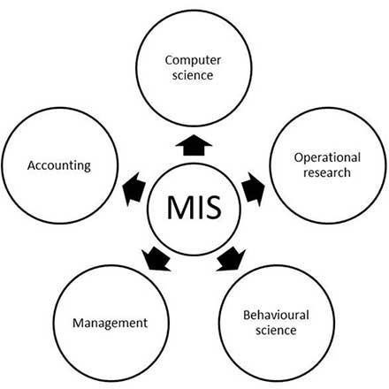

**Structure of MIS:** Structure of MIS may be understood by looking at the physical components of the information system in an organization. The physical components of an organizational information system may be hardware, software, database, manual procedures and operating persons. A brief description of these components has been outlined in the following paragraphs:

Hardware:

Hardware refers to the physical data processing equipment and peripheral devices, For example, CPU, monitor, keyboard, printer, drives, tapes, communication devices, etc.

Software:

Software is a broad term given to the instructions or programs that direct the operating of the hardware. Software could be of two types, i.e. system software and application software.

Database:

The database consists of all data utilized by application software. Data is stored in files.

Procedures:

Formal operating procedures, which are required to operate a system, such as manuals, are also regarded as physical elements.

Operating Personnel:

Personnel like Computer Operators, Computer Programmers, System Analysts, System Managers, etc., are the operating people of the information systems.

Input and Output:

Various physical inputs and outputs from the information system, existing in forms like printout, reports etc**.**

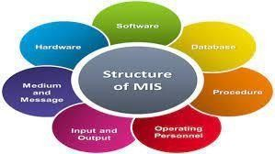

MIS - Classification of Information:

Information can be classified in a number of ways:

1. **Classification by Characteristic** :-Based on Anthony's classification of Management, information used in business for decisionmaking is generally categorized into three types:
   * **Strategic Information**: Strategic information is concerned with long term policy✓ decisions that defines the objectives of a business and checks how well these objectives are met. For example, acquiring a new plant, a new product, diversification of business etc, comes under strategic information.
   * **Tactical Information**: Tactical information is concerned with the information needed for exercising control over business resources, like budgeting, quality control, service level, inventory level, productivity level etc.
   * **Operational Information**: Operational information is concerned with plant/business level information and is used to ensure proper conduction of specific operational tasks as planned/intended. Various operator specific, machine specific and shift specific jobs for quality control checks comes under this category.
2. Classification by Application

In terms of applications, information can be categorized as:

* + **Planning Information**: These are the information needed for establishing standard norms and specifications in an organization. This information is used in strategic, tactical, and operation planning of any activity. Examples of such information are time standards, design standards.
  + **Control Information**: This information is needed for establishing control over all business activities through feedback mechanism. This information is used for controlling attainment, nature and utilization of important processes in a system. When such information reflects a deviation from the established standards, the system should induce a decision or an action leading to control.
  + **Knowledge Information**: Knowledge is defined as "information about information". Knowledge information is acquired through experience and learning, and collected from archival data and research studies.
  + **Organizational Information**: Organizational information deals with an organization’s environment, culture in the light of its objectives. Karl Weick's Organizational Information Theory emphasizes that an organization reduces its equivocality or uncertainty by collecting, managing and using these information prudently. This information is used by everybody in the organization; examples of such information are employee and payroll information.
  + **Functional/Operational Information**: This is operation specific information. For example, daily schedules in a manufacturing plant that refers to the detailed assignment of jobs to machines or machines to operators. In a service oriented business, it would be the duty roster of various personnel. This information is mostly internal to the organization.
  + **Database Information**: Database information construes large quantities of information that has multiple usage and application. Such information is stored,

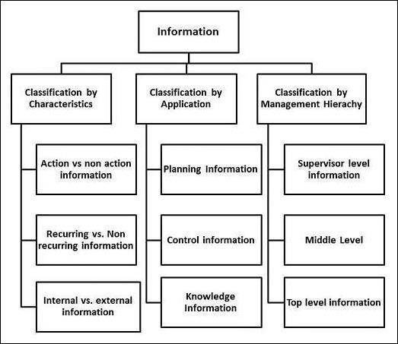

retrieved and managed to create databases. For example, material specification or supplier information is stored for multiple users.

Information and Systems Concept:

An information system (IS) is an organized system for the collection, organization, storage and communication of information. More specifically, it is the study of complementary networks that people and organizations use to collect, filters, and process, create and distribute data.

The concept that information is the message has different meanings in different contexts. Thus the concept of information becomes closely related to notions of constraint, communication, control, data, form, education, knowledge, meaning, understanding, mental stimuli, pattern, perception,

representation, and entropy.

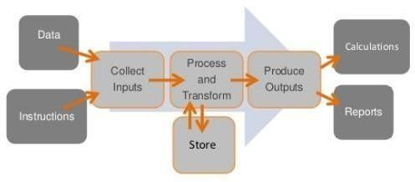

Types of Information Systems:

1. TPS Transaction Processing System
2. MIS Management Information System
3. DSS Decision Support system
4. ESS Executive Support System
5. OAS Office Automation System
6. **TPS** are used primarily for structured operational, and to a lesser degree, management controlapplications.
7. **MIS** are used for semi--structured, management control applications. It also overlaps into the operational and strategic planning realms as well.
8. **DSS** are used primarily for unstructured decision-making whether that occurs at theoperational, management and strategic planning levels.
9. **ESS** is used primarily for structured management and strategic planning applications.
10. **OAS** are used as a facilitator of office correspondence and communication,

underlies all ofthis activity.

A typical organization is divided into operational, middle, and upper level. The information requirements for users at each level differ. Towards that end, there are number of informationsystems that support each level in an organization.

* + Pyramid Diagram of Organizational levels and information requirements
  + Transaction Processing System (TPS)
  + Management Information System (MIS)
  + Decision Support System (DSS)
  + Artificial intelligence techniques in business
  + Online Analytical Processing (OLAP)

Pyramid Diagram of Organizational levels and information requirements

Understanding the various levels of an organization is essential to understand the information required by the users who operate at their respective levels.

The following diagram illustrates the various levels of a typical organization.

Operational Management Level

The operational level is concerned with performing day to day business transactions of the organization.

Examples of users at this level of management include cashiers at a point of sale, bank tellers, nurses in a hospital, customer care staff, etc.

Users at this level use make structured decisions. This means that they have defined rules that guides them while making decisions.

For example, if a store sells items on credit and they have a credit policy that has some set limit on the borrowing. All the sales person needs to decide whether to give credit to a customer or not is based on the current credit information from the system.

Tactical Management Level

This organization level is dominated by middle-level managers, heads of departments, supervisors, etc. The users at this level usually oversee the activities of the users at the operational management level.

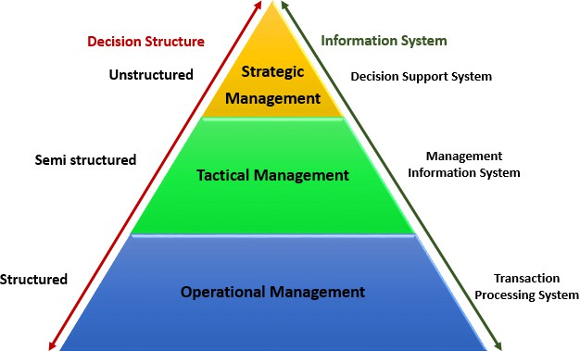

Tactical users make semi-structured decisions. The decisions are partly based on set guidelines and judgmental calls. As an example, a tactical manager can check the credit limit and payments history of a customer and decide to make an exception to raise the credit limit for a particular customer. The decision is partly structured in the sense that the tactical manager has to use existing information to identify a payments history that benefits the organization and an allowed increase percentage.

Strategic Management Level

This is the most senior level in an organization. The users at this level make unstructured decisions. Senior level managers are concerned with the long-term planning of the organization. They use information from tactical managers and external data to guide them when making unstructured decisions.

Transaction Processing System (TPS)

Transaction processing systems are used to record day to day business transactions of the organization. They are used by users at the operational management level. The main objective of a transaction processing system is to answer routine questions such as;

* + How printers were sold today?
  + How much inventory do we have at hand?
  + What is the outstanding due for John Doe?

By recording the day to day business transactions, TPS system provides answers to the abovequestions in a timely manner.

* The decisions made by operational managers are routine and highly structured.
* The information produced from the transaction processing system is very detailed. For example, banks that give out loans require that the company that a person works for should have a memorandum of understanding (MoU) with the bank. If a person whose

employer has a MoU with the bank applies for a loan, all that the operational staff has to do is verify the submitted documents. If they meet the requirements, then the loan application documents are processed. If they do not meet the requirements, then the client is advised to see tacticalmanagement staff to see the possibility of signing a MoU.

Examples of transaction processing systems include

* + Point of Sale Systems – records daily sales
  + Payroll systems – processing employees salary, loans management, etc.
  + Stock Control systems – keeping track of inventory levels
  + Airline booking systems – flights booking management.

Management Information System (MIS)

Management Information Systems (MIS) are used by tactical managers to monitor the organization's current performance status. The output from a transaction processing system is used as input to a management information system.

The MIS system analyzes the input with routine algorithms i.e. aggregate, compare and summarizes the results to produced reports that tactical managers use to monitor, control and predict future performance.

For example, input from a point of sale system can be used to analyze trends of products that are performing well and those that are not performing well. This information can be used to make future inventory orders i.e. increasing orders for well-performing products and reduce the orders of products that are not performing well.

Examples of management information systems include

* **Sales management systems** – they get input from the point of sale system
* **Budgeting systems** – gives an overview of how much money is spent within the organization for the short and long terms.
* **Human resource management system** – overall welfare of the employees, staff turnover, etc.

Tactical managers are responsible for the semi-structured decision. MIS systems provide the information needed to make the structured decision and based on the experience of the tactical managers, they make judgement calls i.e. predict how much of goods or inventory should be ordered for the second quarter based on the sales of the first quarter.

Decision Support System (DSS)

Decision support systems are used by senior management to make non-routine decisions. Decision support systems use input from internal systems (transaction processing systems and management information systems) and external systems.

The main objective of decision support systems is to provide solutions to problems that are

unique and change frequently. Decision support systems answer questions such as;

* What would be the impact of employees' performance if we double the production lot at the factory?
* What would happen to our sales if a new competitor entered the market? Decision support systems use sophisticated mathematical models, and statistical techniques (probability, predictive modeling, etc.) to provide solutions, and they are very interactive.

Examples of decision support systems include

* + **Financial planning systems –** it enables managers to evaluate alternative ways of achieving goals. The objective is to find the optimal way of achieving the goal. For example, the net profit for a business is calculated using the formula Total Sales less (Cost of Goods + Expenses). A financial planning system will enable senior executives to ask what if questions and adjust the values for total sales, the cost of goods, etc. to see the effect of the decision and on the net profit and find the most optimal way.
  + **Bank loan management systems –** it is used to verify the credit of the loan applicant and predict the likelihood of the loan being recovered.

###### Artificial intelligence techniques in business

Artificial intelligence systems mimic human expertise to identify patterns in large data sets. Companies such as Amazon, Facebook, and Google, etc. use artificial intelligence techniques to identify data that is most relevant to you.

Let's use Facebook as an example, Facebook usually makes very accurate predictions of people that you might know or went with to school. They use the data that you provide to them, the data that your friends provide and based on this information make predictions of people that you might know.

Amazon uses artificial intelligence techniques too to suggest products that you should buy also based on what you are currently getting.

Google also uses artificial intelligence to give you the most relevant search results based on yourinteractions with Google and your location.

These techniques have greatly contributed in making these companies very successful because they are able to provide value to their customers.

Online Analytical Processing (OLAP)

Online analytical processing (OLAP) is used to query and analyze multi-dimensional data and produce information that can be viewed in different ways using multiple dimensions.

Let's say a company sells laptops, desktops, and Mobile device. They have four (4) branches A, B, C and D. OLAP can be used to view the total sales of each product in

all regions and compare the actual sales with the projected sales. Each piece of information such as product, number of sales, sales value represents a different dimension The main objective of OLAP systems is to provide answers to ad hoc queries within the shortest possible time regardless of the size of the datasets being used.

Information Systems for Competitive Advantage

In Management Information Systems by Effy Oz (2008), there are eight ways to gain competitive advantage: Reducing cost, raising barriers to market entrants, establishing high switching costs, creating new products or services, differentiating products or services, enhancing products or services, establishing alliances.

Locking in suppliers or buyers Competitive Advantage in any industry or business venture is achieved when one particular organization performs more effectively and/or efficiently than the others in the same category. This Competitive Advantage does not have to be all encompassing of the industry and may only cover small segments. A Competitive Advantage is achieved when an organization can do any one thing, process, function, etc. more effectively and or efficiently than others in that industry segment or in some cases across the entire industry.

According to the authors W.R. King, V. Grove, and E.H. Hufnagel (1989), information technology is used as a strategic tool for companies to increase their competitive advantage at a time when uncertainty is growing. The idea that information technology can contribute to the optimization of enterprise resources, enhances, enable and enhance business performance. This idea was accepted and supported by many empirical studies (V. Sethi and WR King, 1994), (Chan, SL Huff, DW Barclay, 1997), (AM Croteau and F. Bergeron, 2001).

Authors Rackoff, Wiseman, and Ullrich (1985) have identified several factors that ensure computerization of competitive advantage of enterprises. They are:

* Modification, differentiation or changes that make the company stand out with its products and services or weaken competition and reduce the competitive advantages;
* Adapting and adjusting supply cutting costs, reducing consumer spending and increasing competition expenses;
* Company being introduced innovative products or services that result in changes in the way business is passed then in the industry;
* Improving growth and development by increasing volume, expanding geographically and being harmonized with suppliers and customers;
* Forms of mergers and alliances through various agreements in marketing etc.Since the business environment is constantly changing and evolving, the business itself changes all the time and with the growth and development information needs to ask businesses will vary. At the same time computing system needs to support growth, change and development. (Vakola and Wilson, 2004). The findings of the authors mentioned above clearly show that businesses invest in computing technology, because they believe that this technology will enable them to be more competitive (Malaga A. Ross, 2001).

Some other authors Urwiller and Florick (2008) noted that to create competitive difference as a result of computerization first condition are innovations in information technology, which today have become an integral part of organizational strategy and planning processes. Information Technology is not only possible, but is streamlined entity and the way to create competitive edge. To achieve competitive difference information technology and its use in business processes results in a new way of doing business (e-business) as well as providing products and services electronically. So information technology plays a crucial role in supporting the business by creating competitive advantage (Competitive Advantage), offering services and products so that customers appreciate more than the competition. This technology is able to provide operational excellence (Operational excellence), initiatives in key business branches (Major Business Initiatives) then the decision (Decision Making) and organizational transformation (Organizational Transformation). In what manner is information technology provides operational perfection (Operational Excellence) being efficient in what we do, using transaction-processing systems within the organization Transaction processing system (TPS) using Customer self-service systems(CSS) to make their offer customers their transaction processing etc.